UNIVERSITI TUNKU ABDUL RAHMAN

ACADEMIC YEAR 2024/2025

UCCD 1004 PROGRAMMING CONCEPTS AND PRACTICES

ASSIGNMENT 2

Group XX
Name | ID | Programme | UTAR Email
CHENG YI SHEN | 2304951 | CT | yishen0702@1utar.my
LIEW ZHENG JACK | 2305012 | CT | liewzhengjack123@1utar.my
YONG WEI SHENG | 2302754 | CT | yongws0105@1utar.my

Task Division
 | Name | Role | Modules
1. | CHENG YI SHEN | 1 | readUser
 |  |  | registration
 |  |  | login
2. | LIEW ZHENG JACK | 3 | readPaymentCheckIn
 |  |  | payment
 |  |  | checkIn
3. | YONG WEI SHENG | 2 | readBooking
 |  |  | performBooking
 |  |  | editBooking

Objective
The main objectives are to provide a user-friendly system for users to do online booking for flight tickets, perform payment and check in details safely online with simple steps as well as facilitate flight management and storing of important details of passengers, which aims to save passengers’ time at the airport. The program is also expected to perform the features below:
- Allow passengers to register an account on JSJK website and store details of the registered accounts.
- Validates passengers’ username and password during login process to secure user login access to the program.
- Allow passengers to perform booking for their desired flight tickets.
- Store and utilize booking details of passengers to facilitate payment and check in processes.
- Allow passengers to edit booking details to provide flexibility and improve customer satisfaction.
- Allow passengers to perform payment online for greater convenience and improve customers’ accessibility
- Allow passengers to check in their personal details and contact person details.
- Store passengers’ payment and check in details in an orderly manner and utilize them to enhance flight arrangement as well as provide safe, efficient and responsible air travel management.
- Allow passengers to print invoices for their booking as proof of purchase and maintain a clear record of their bookings.

The program aims to improve the JSJK airline company’s overall online booking system by implementing strict input validations to minimize errors and ensure data integrity. With this, the system will easily prevent common issues such as invalid booking details, incorrect payment information format and incorrect passengers’ details.

Pseudocode
Main()
BEGIN main
Initialize userCount to 0
Initialize contRL and cont to 1
Declare variable for user choice
Declare array of users
Read registered users into the array
DO
Display header and main menu (Register, Login, Quit)
Prompt user for a choice
IF choice is 1 THEN
Clear screen
Register a new user
Refresh user list
Ask if user wants to continue with registration/login
IF answer is no THEN
Say goodbye and EXIT
ELSE IF choice is 2 THEN
Refresh user list
Call login function with current user
SWITCH login result:
CASE 1:
Successful login → exit loop
CASE 2:
Incorrect password → show message
CASE 3:
Incorrect username → show message
CASE 4:
Both incorrect → show message
IF login failed THEN
Suggest registering
Ask if want to continue
IF answer is no THEN
Clear screen, say goodbye, and EXIT
ELSE IF choice is 3 THEN
Say goodbye and EXIT
ELSE
Handle invalid input
END IF
Clear screen
WHILE contRL is 1
DO
Clear screen and display logged-in user menu
Show booking, editing, payment, check-in, invoice, quit options
Read booking and check-in data
Get validated menu selection
SWITCH selection:
CASE 1:
Book ticket and store booking
CASE 2:
Edit existing booking
CASE 3:
IF no booking → show error
ELSE IF already paid → show error
ELSE → process payment
CASE 4:
IF no booking → show error
ELSE IF not paid → show error
ELSE IF already checked in → show error
ELSE → perform check-in
CASE 5:
IF no booking → show error
ELSE IF not paid → show error
ELSE IF not checked in → show error
ELSE → print invoice
CASE 6:
Clear screen, say goodbye, set cont to 0 to exit loop
DEFAULT:
Show not available message
IF selection is 1 or 2 THEN
IF booking file exists THEN
Create payment/check-in/invoice file
END IF
END IF
WHILE cont is 1
RETURN 0
END main

void readUser(Registration users[SIZE], int& userCount)
START function
DEFINE line as string
OPEN file "user.txt" FOR reading
SET userCount TO 0
IF file is open THEN
WHILE not end of file DO
READ first_name from file
READ last_name from file
READ mobile_number from file
READ email from file
READ username from file
READ password from file
STORE all read data into users[userCount]
INCREMENT userCount by 1
END WHILE
CLOSE file
ELSE // Do nothing
END IF
END FUNCTION

registration()
START function
DEFINE first_name, last_name, mobile_number, email, username, password1, password2 as string
DEFINE confirm, choice as char
DEFINE notEqualCount as int
DO
DISPLAY header and registration prompt
DO // First Name
PROMPT user for first name
IF first name is empty THEN
DISPLAY error: "It cannot be blank"
CONTINUE
IF first name contains non-letters THEN
DISPLAY error: "Name must contain only letters"
CONTINUE
WHILE input is invalid
FORMAT first name
DO // Last Name
PROMPT user for last name
IF last name is empty THEN
DISPLAY error
CONTINUE
IF last name contains non-letters THEN
DISPLAY error
CONTINUE
WHILE input is invalid
FORMAT last name
DO // Mobile Number
PROMPT user for mobile number
IF input contains non-digits THEN
DISPLAY error
CONTINUE
IF number format is invalid THEN
IF not starting with "01" THEN
DISPLAY error
CONTINUE
IF starts with "011" AND length is not 11 THEN
DISPLAY error
CONTINUE
IF not "011" AND length is not 10 THEN
DISPLAY error
CONTINUE
WHILE input is invalid
DO // Email
PROMPT user for email
IF email is empty THEN
DISPLAY error
CONTINUE
IF email format is invalid THEN
DISPLAY error
CONTINUE
WHILE input is invalid
DO// Username
PROMPT user for username
IF username is empty THEN
DISPLAY error
CONTINUE
IF username contains non-letters THEN
DISPLAY error
CONTINUE
IF username is a duplicate THEN
DISPLAY error
CONTINUE
WHILE input is invalid
DO // Password
DO
PROMPT user for password
IF password is not strong THEN
DISPLAY error
WHILE password is not strong
SET attempt count TO 0
DO
PROMPT user to re-enter password
IF passwords do not match THEN
INCREMENT attempt count
DISPLAY error
IF attempt count == 3 THEN
DISPLAY error
BREAK
WHILE passwords do not match AND attempts < 3
WHILE attempt count == 3
DO // Confirm Registration
PROMPT "Confirm to register? (y/n)"
IF confirm is 'y' THEN
APPEND user data to "user.txt"
DISPLAY "Registration done"
ELSE IF confirm is 'n' THEN
DISPLAY "Registration cancelled"
DO
PROMPT "Register again or quit? (r/q)"
IF input is 'q' THEN
DISPLAY "Quitting..."
RETURN
ELSE IF input is 'r' THEN
DISPLAY "Returning to registration..."
BREAK
ELSE
DISPLAY "Invalid input"
WHILE input is not 'q' or 'r'
ELSE
DISPLAY "Invalid choice"
WHILE confirm is not 'y' or 'n'

CLEAR screen
WHILE confirm is 'n'
END FUNCTION

int login(Registration users[SIZE], int& userCount, string& currentUser)
START function
DEFINE inputUserName, inputPassword as string
CLEAR the screen
DISPLAY login header and formatting
PROMPT user to enter username
READ inputUserName
PROMPT user to enter password
READ inputPassword
SET usernameFound TO false
SET passwordCorrect TO false
FOR i FROM 0 TO userCount - 1 DO
IF users[i].username EQUALS inputUserName AND users[i].password EQUALS inputPassword THEN
SET currentUser TO inputUserName
DISPLAY "Login Successfully!"
DISPLAY "Welcome, currentUser!"
CALL clearline("Redirecting to the login page...")
RETURN 1 // Login successful
END IF
IF users[i].username EQUALS inputUserName THEN
SET usernameFound TO true
END IF
IF users[i].password EQUALS inputPassword THEN
SET passwordCorrect TO true
END IF
END FOR
IF usernameFound IS true THEN
RETURN 2 // Username exists but password is incorrect
ELSE IF passwordCorrect IS true THEN
RETURN 3 // Password correct but username is incorrect
ELSE
RETURN 4 // Both username and password are incorrect
END IF
END FUNCTION

editBooking()
IF noTickets == 0 THEN
DISPLAY "No booking available to edit"
PAUSE and CLEAR screen
RETURN
END IF
DISPLAY flight schedule
ASK user: "Change Passenger Name (Y/N)?"
VALIDATE input for 'Y' or 'N'
IF user chooses 'Y' THEN
CLEAR screen
DISPLAY "Name Editing"
ASK for passenger's first name
VALIDATE name input
FOR each booking in flight[]
IF current passenger's first name matches input THEN
ASK for new first and last names
VALIDATE both names
UPDATE passenger name
SET edited = true
SET found = true
BREAK loop
END IF
END FOR
IF passenger not found THEN
DISPLAY "Passenger does not exist"
PAUSE and CLEAR screen
RETURN
END IF
ELSE IF user chooses 'N' THEN
CLEAR screen
DISPLAY "Edit Booking Menu"
CALL editMenu() to show options
READ editChoice
SWITCH editChoice:
CASE 1: EDIT departure flight
VALIDATE flight number (1 to 8)
UPDATE and SET edited = true
CASE 2: EDIT departure date
VALIDATE date is not empty and before return date
UPDATE and SET edited = true
CASE 3: EDIT departure time slot
VALIDATE slot (1 to 4)
UPDATE and SET edited = true
CASE 4: EDIT return flight
VALIDATE flight number (1 to 8)
UPDATE and SET edited = true
CASE 5: EDIT return date
VALIDATE date is not empty and after departure date
UPDATE and SET edited = true
CASE 6: EDIT return time slot
VALIDATE slot (1 to 4)
UPDATE and SET edited = true
DEFAULT:
DISPLAY "Invalid Choice"
END SWITCH
END IF
IF edited THEN
ASK user to confirm save (Y/N)
VALIDATE input
IF user chooses 'Y' THEN
OPEN booking file for currentUser
WRITE all flight[] data to file
CLOSE file
DISPLAY "Booking updated successfully"
ELSE
DISPLAY "Edit cancelled"
END IF
PAUSE and CLEAR screen
END IF

readBooking()
OPEN booking file for currentUser
IF file fails to open THEN
// Do nothing (noTickets remains unchanged)
ELSE
SET noTickets = 0
WHILE not end of file
READ first name
IF first name is empty THEN BREAK
READ last name
READ departure flight
READ departure date
READ departure time
READ return flight
READ return date
READ return time
INCREMENT noTickets
END WHILE
CLOSE file
END IF

performBooking()
Function performBooking:
Declare variables:
confirmBooking (char)
noTickets (int)
maxTickets = 20
flight[20] as BookingDetails array
Call FlightSchedule()
Prompt user: "Number of Passenger(s):"
Input noTickets
While noTickets is invalid (non-number, ≤ 0, or > maxTickets):
Display error and re-prompt
Clear screen
Call FlightSchedule()
Prompt user for shared flight details:
Input sharedDepartureFlight (1–8)
While invalid, re-prompt
Input sharedDepartureDate
While empty or invalid, re-prompt
Input sharedDepartTime (1–4)
While invalid, re-prompt
Input sharedReturnFlight (1–8)
While invalid or not matching destination, re-prompt
Input sharedReturnDate
While empty or not after departure date, re-prompt
Input sharedReturnTime (1–4)
While invalid, re-prompt
For each passenger from 1 to noTickets:
Clear screen
Call FlightSchedule()
Prompt: "First name:"
Input first_name
While empty or non-alphabetic, re-prompt
Prompt: "Last name:"
Input last_name
While empty or non-alphabetic, re-prompt

Assign shared flight details to flight[i]
Display summary of all passenger bookings
Repeat:
Prompt: "Confirm booking? (Y/N)"
Input confirmBooking
If confirmBooking is 'Y' or 'y':
Open booking file for appending
If file fails:
Show error
Else:
Write each passenger's details to file
Display "Booking successfully recorded."
Close file
Exit loop
Else if confirmBooking is 'N' or 'n':
Display "Booking is canceled!"
Exit loop
Else:
Show invalid input message
Prompt user to press enter to return to main menu
Wait for input
Clear screen
End Function

void payment()
START payment()
Initialize double dpaertticketPrice[9] = { 0, 200, 200, 200, 200, 250, 250, 300, 300 }
Initialize double returnticketPrice[9] = { 0, 200, 200, 200, 200, 250, 250, 300, 300 }
Initialize string departFromTo[9] = { "", "KL - Penang", "Penang - KL", "KL - Johor", "Johor - KL", "KL - Singapore", "KL - Singapore", "KL - Bangkok", "Bangkok - KL" }
Initialize string returnFromTo[9] = { "", "KL - Penang", "Penang - KL", "KL - Johor", "Johor - KL", "KL - Singapore", "KL - Singapore", "KL - Bangkok", "Bangkok - KL" }
Initialize string departClockTime[9] = { "8:00 A.M.", "1:00 P.M.", "6:00 P.M.", "11:00 P.M." }
Initialize string returnClockTime[9] = { "8:00 A.M.", "1:00 P.M.", "6:00 P.M.", "11:00 P.M." }
Initialize BookingDetails flight_details = flight[0]
Initialize double TotalPrice = (departticketPrice[flight_details.departureFlight] + returnticketPrice[flight_details.returnFlight]) * noTickets
Declare char payment, transact
Display noTickets, flight_details.departureDate, departFromTo[flight_details.departureFlight, departClockTime[flight_details.departTime], flight_details.returnDate, returnFromTo[flight_details.returnFlight], returnClockTime[flight_details.returnTime], departticketPrice[flight_details.departureFlight], returnticketPrice[flight_details.returnFlight], TotalPrice
Input payment
Clear screen
IF payment == ‘y’ or ‘Y’
Declare int payment_option
Input payment_option
WHILE payment_option < 1 or > 2
Input payment_option
System clear
End while
IF payment_option = 1 then
Input card_holder, card_num, card_date, card_code
ELSE IF payment_option = 2 then
declare string bank_account
declare int bankname
input bankname, bank_account
End if
Input transact
IF transact == ‘Y’ or ‘y’ then
OPEN paymentCheckIn file
Write TotalPrice to paymentCheckIn
Write “Paid” to paymentCheckIn
FOR i in range of 6 * noTickets
Write “NULL” to paymentCheckIn
Write “Not Check” to paymentCheckIn
Close paymentCheckIn file
Display “Transaction Completed Successfully!”
Display “Payment Status Paid”
ELSE
Display “Transaction Cancelled. “
End if
ELSE
Display “Back to main menu”
END IF
END payment()

void checkIn(CheckIn_Details& details)
START checkIn(details)
Declare char checkInConfirmation
Display “Payment Status: Paid”
Display “~Proceed to check in~”
FOR each passenger from 0 to (noTickets – 1)
Display “Passenger”, i + 1
DO
Input details.passenger_flight[i].CheckIn_name.first_name,
Validate details.passenger_flight[i].CheckIn_name.first_name
IF invalid then
Display error message
WHILE details.passenger_flight[i].CheckIn_name.first_name is VALID
END DOWHILE
DO
Input details.passenger_flight[i].CheckIn_name.last_name
Validate details.passenger_flight[i].CheckIn_name.last_name
IF invalid then
Display error message
WHILE details.passenger_flight[i].CheckIn_name.first_name is VALID
END DOWHILE

DO
Input details.passenger_flight[i].passport_num
Validate details.passenger_flight[i].passport_num
IF invalid then
Display error message
WHILE details.passenger_flight[i].passport_num is VALID
END DOWHILE
IF i = 0
Input details.passenger_flight[i].contact_name.first_name, details.passenger_flight[i].contact_name.last_name, details.passenger_flight[i].mobile_num
ELSE
Declare char reuse
input reuse
IF reuse = ‘y’ or ‘Y’
IF i > 1
Declare int contactChoice
Input contactChoice
details.passenger_flight[i].contact_name = details.passenger_flight[contactChoice - 1].contact_name;
details.passenger_flight[i].mobile_num = details.passenger_flight[contactChoice - 1].mobile_num;
ELSE
details.passenger_flight[i].contact_name = details.passenger_flight[0].contact_name;
details.passenger_flight[i].mobile_num = details.passenger_flight[0].mobile_num;
ELSE
input details.passenger_flight[i].contact_name.first_name, details.passenger_flight[i].contact_name.last_name, details.passenger_flight[i].mobile_num
Input checkInConfirmation
IF checkInConfirmation == ‘y’ or ‘Y’
System clear
details.checkIn_status = “Checked”
OPEN paymentCheckIn file for writing
Write details.total_price, details.payment_status
FOR each noTickets
Write details.passenger_flight[i].CheckIn_name.first_name, details.passenger_flight[i].CheckIn_name.last_name, details.passenger_flight[i].passport_num, details.passenger_flight[i].contact_name.first_name, details.passenger_flight[i].contact_name.last_name, details.passenger_flight[i].mobile_num in checkInPayment
Write details.checkIn_status
checkInPayment.close()
ELSE
Display “Back to main menu”
END IF
Close paymentCheckIn file
END checkIn()

void readPaymentCheckIn(CheckIn_Details details)
START readPaymentCheckIn(details)
Open paymentCheckIn file for read
IF paymentCheckIn file does not exist
RETURN
ELSE
READ details.total_price from paymentCheckIn
Ignore newline character
Read details.payment status from paymentCheckIn
FOR each noTickets
Read details.passenger_flight[i].CheckIn_name.first_name
Read details.passenger_flight[i].CheckIn_name.last_name
Read details.passenger_flight[i].passport_num
Read details.passenger_flight[i].contact_name.first_name
Read details.passenger_flight[i].CheckIn_name.last_name
Read details.passenger_flight[i].contact_name.last_name
Read details.passenger_flight[i].mobile_num
Read checkin_status from paymentCheckIn
END For
END IF
Close paymentCheckIn file
END readpaymentCheckIn(details)

void printInvoice (CheckIn_Details PassengerInforList, BookingDetails BookingList[])
Start printInvoice (details, flight[0])
Open invoice file
IF file failed to open then
Display “No booking available”
Close invoice file
ELSE
Close invoice file
Open invoice file for writing
Write “Welcome to CLS Airline Company”
Write “Departure Flight:”, BookingList[0].departureFlight
Write “Departure Date:”, BookingList[0].departureDate
Write “Departure Slot:” , BookingList[0].departTime
Write “Return Flight:” , BookingList[0].returnFlight
Write “Return Date:” , BookingList[0].returnDate
Write “Return Slot:” , BookingList[0].returnTime
FOR i each noTickets
Write “Passenger “, i + 1
Write “Name:”, PassengerInfoList.passenger_flight[i].CheckIn_name.first_name, PassengerInfoList.passenger_flight[i].CheckIn_name.last_name
Write “Passport Number:”, PassengerInfoList.passenger_flight[i].passport_num i
Write “Contact Person:”, PassengerInfoList.passenger_flight[i].contact_name.first_name, PassengerInfoList.passenger_flight[i].contact_name.last_name
Write “Contact Person Mobile No:”, PassengerInfoList.passenger_flight[i].mobile_num
END FOR
Close invoice file
Display “Invoice printed, please check your folder!”
END IF
END printInvoice

Flowchart
Main()
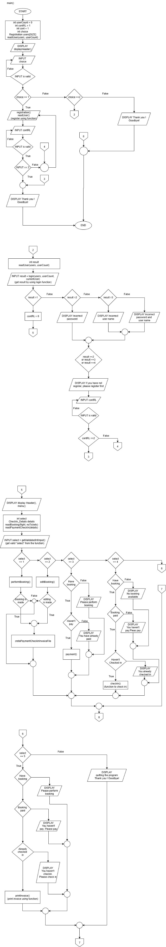


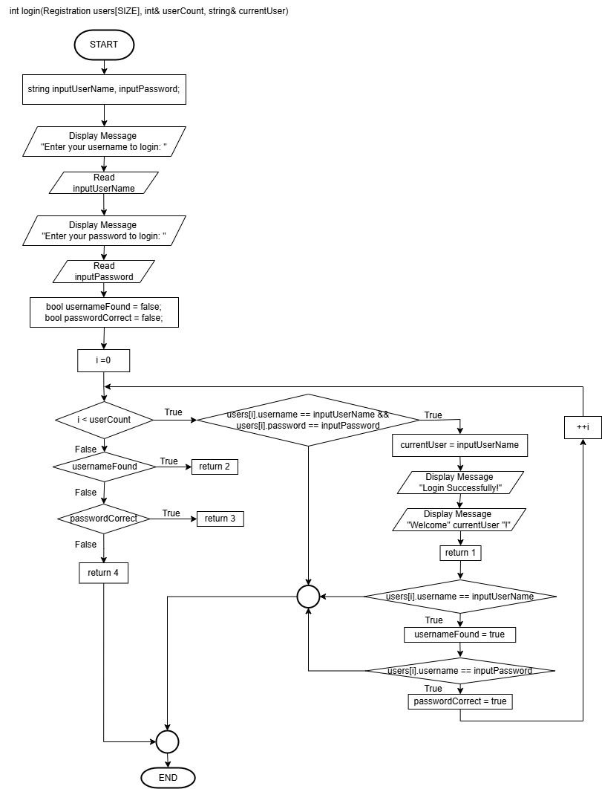

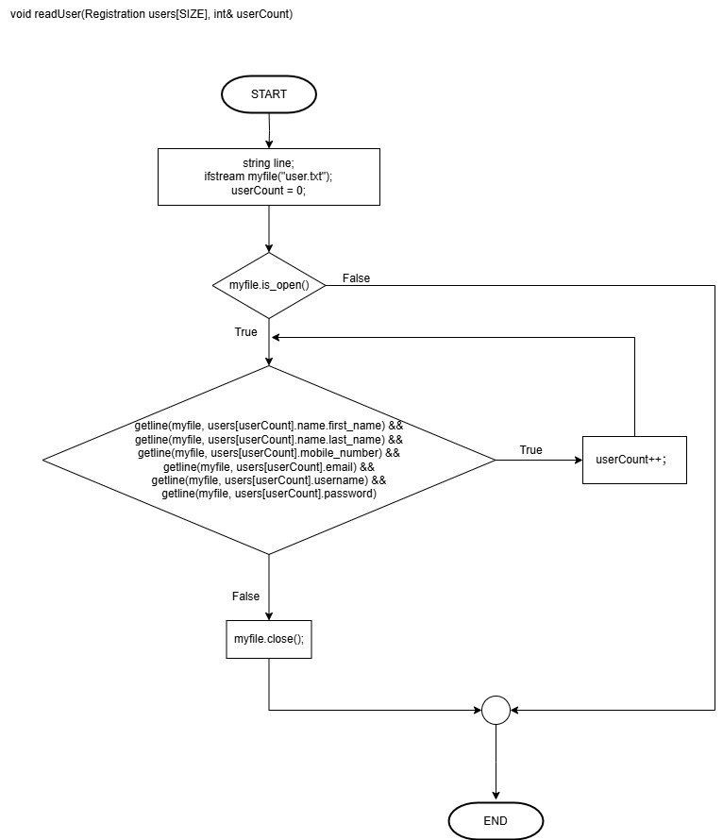

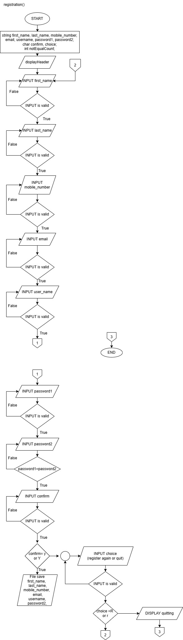



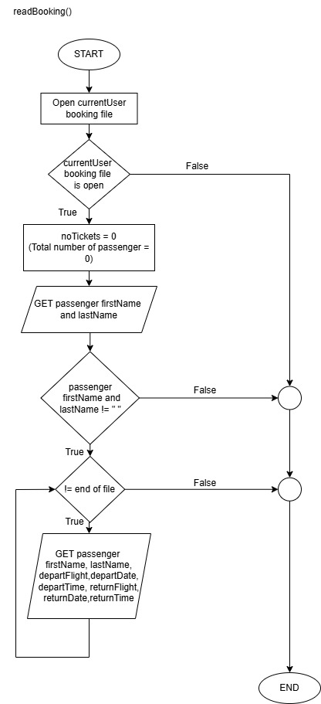

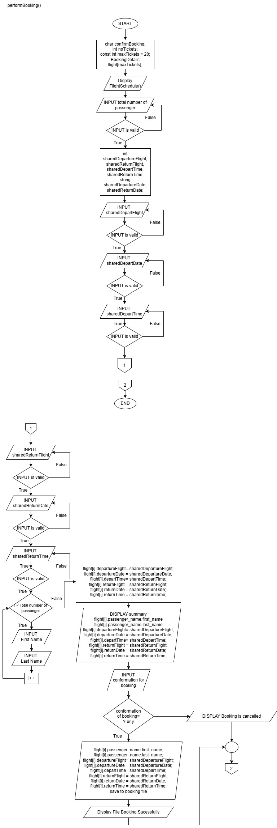

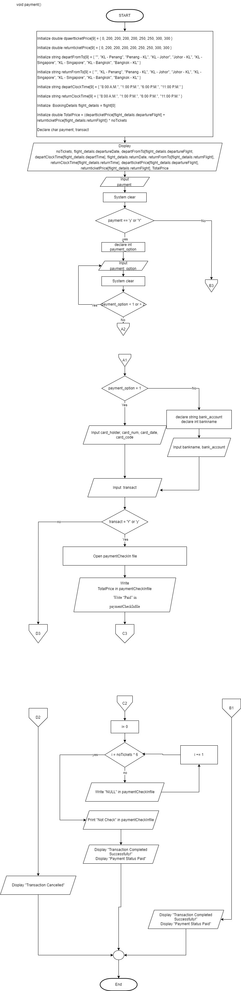



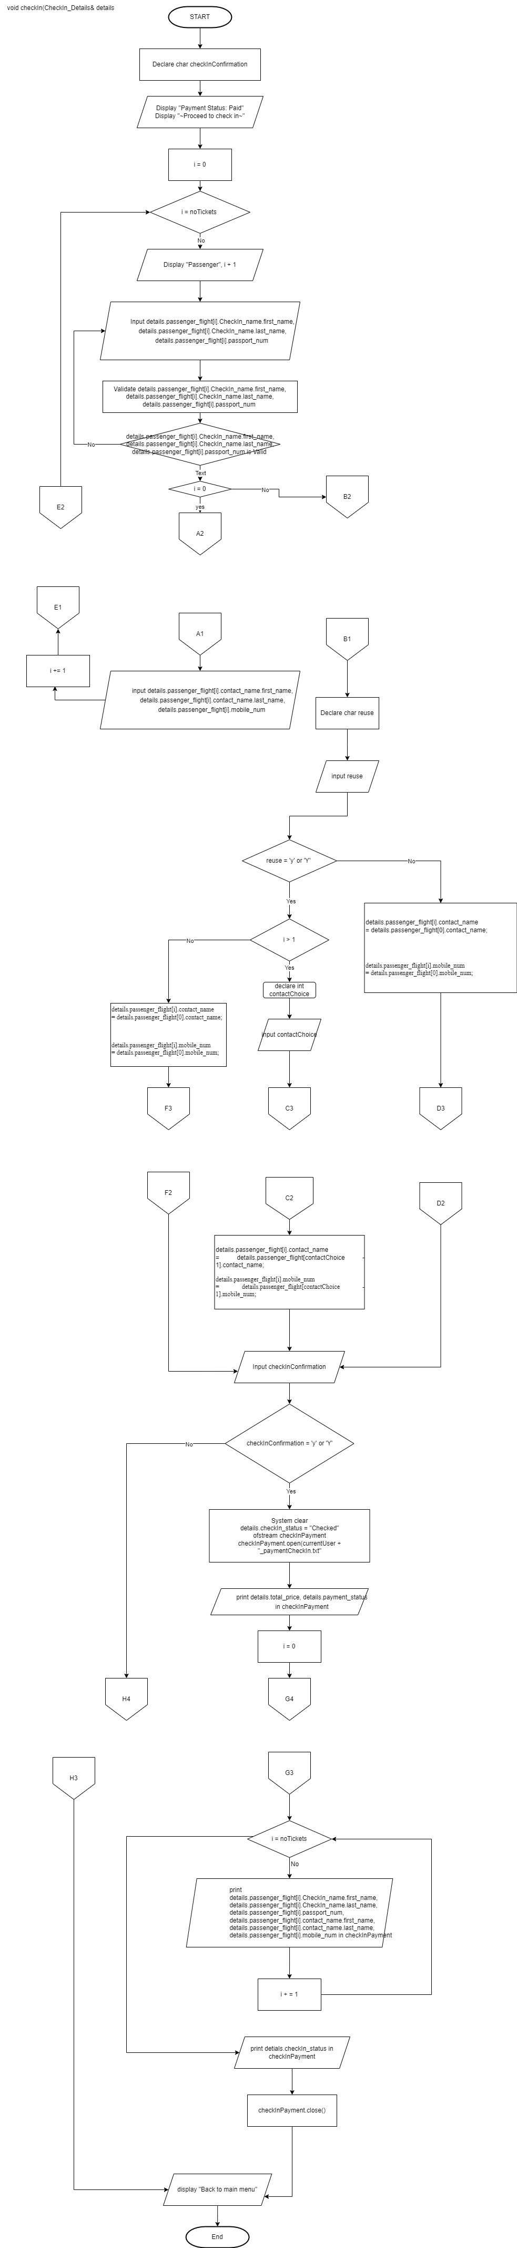



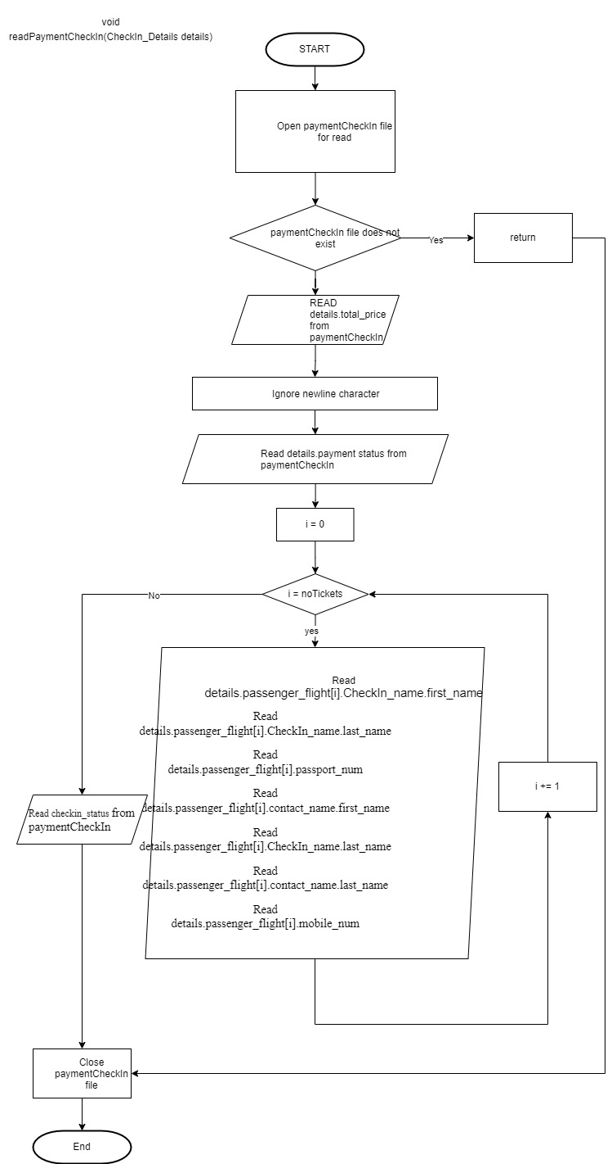

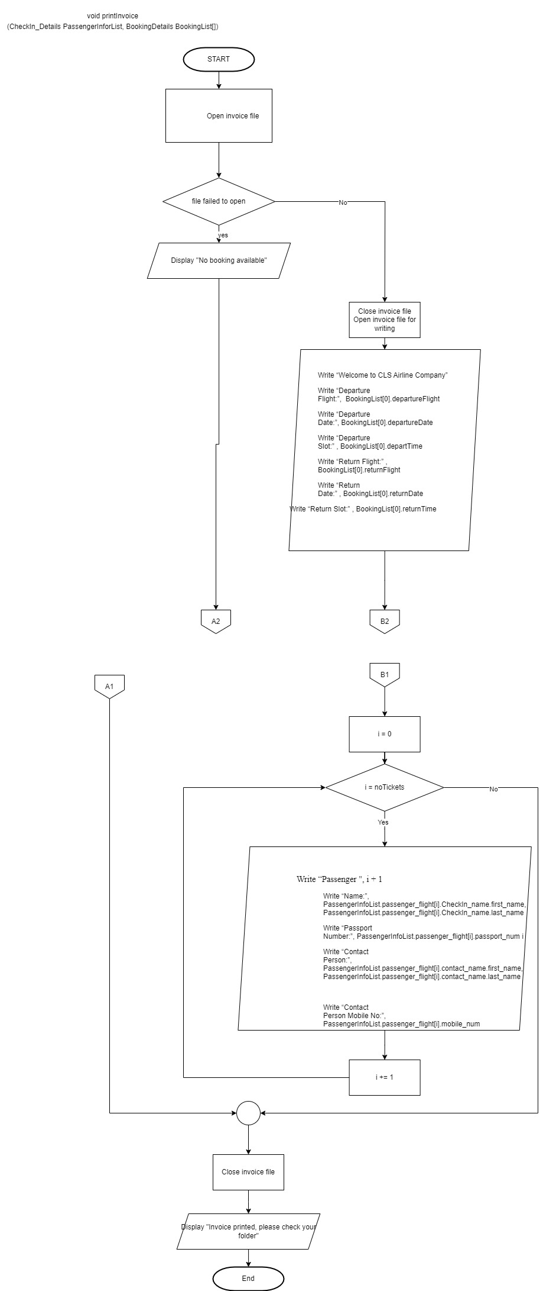

Test cases
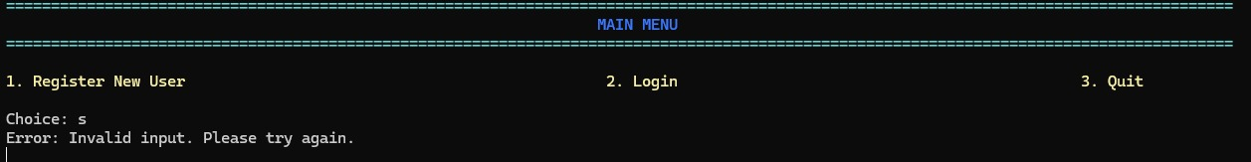
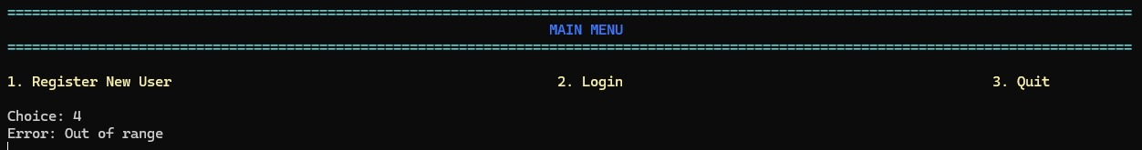
Test case 1 (Registration)

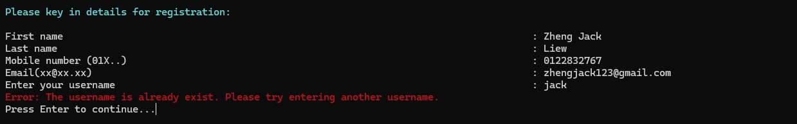
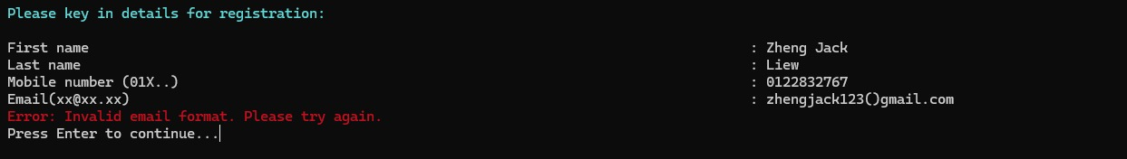
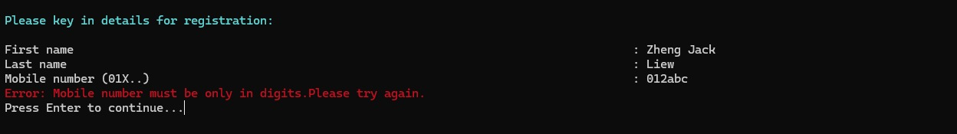
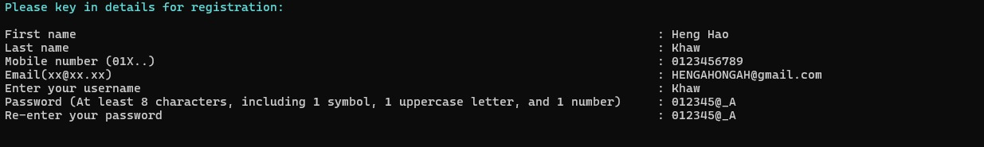
The above screenshots of two different inputs show the program’s validation of users’ choice input. The program will inform users to enter choice within the range when their input is out of range (1st screenshot). When the input is an integer, it will also inform users that it is an invalid input. (2nd screenshot).

Users are required to insert first name, last name, mobile number, email, username and password with certain format to register an account. The program will strictly validate each input’s format, for example “Error: Mobile number must be only in digits. Please try again.” will be displayed when the mobile number inserted is not in the correct format. The program will also verify whether if an account has already existed by matching the inserted username with the account details stored in user text file ( _user.txt ). When every input meets the format requirements, the details registered will be store in the same text file.
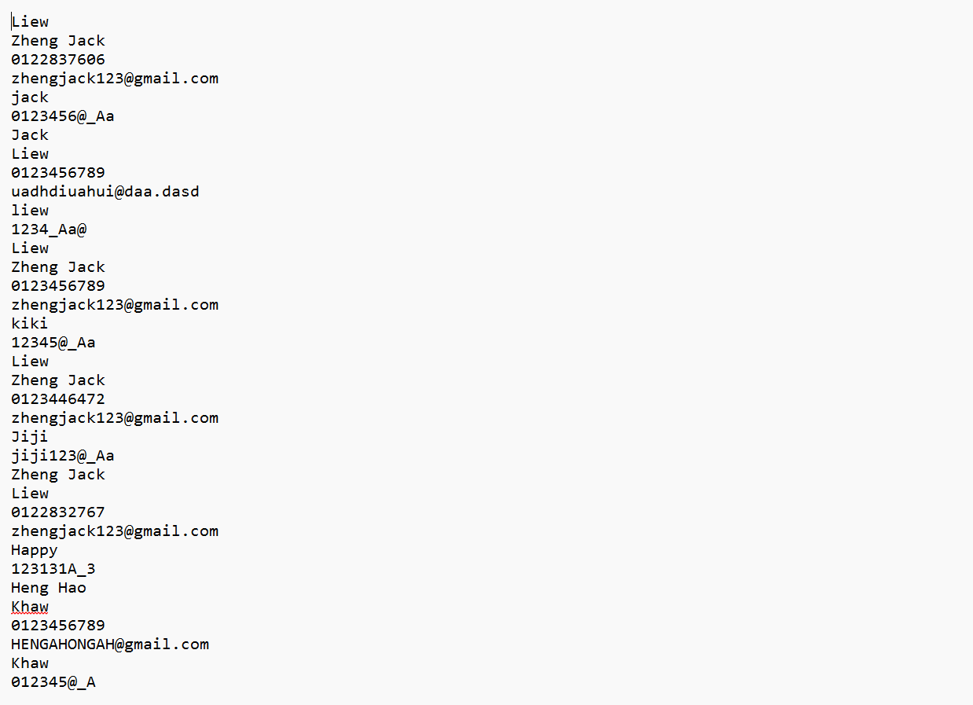
user.txt
Test case 2 (Login)
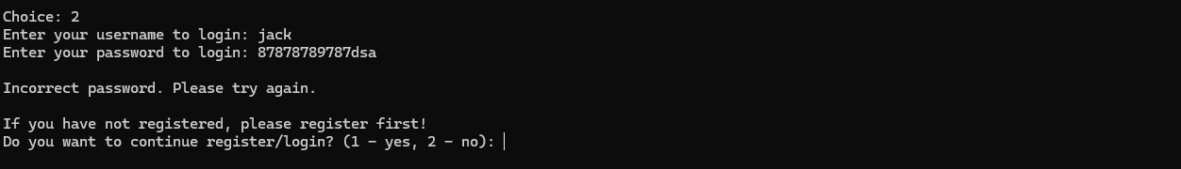
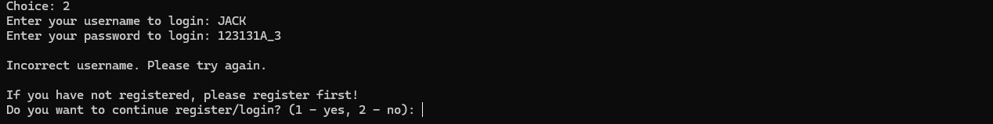
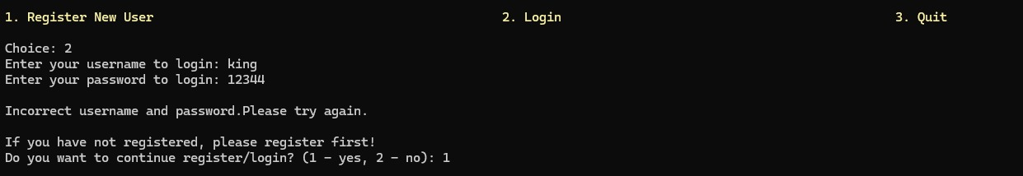
For the login section, the users can only login to their account when only both username and password exist and match each other. The program will read user.txt to verify whether the user’s username and password matches. Incorrect input of either one of the inputs will be informed. After the user successfully logged into their account, the program will lead the user to the next section.

Test case 3 (Perform Booking)
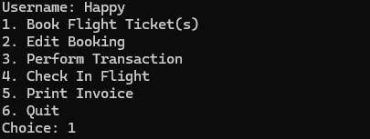
Section 2
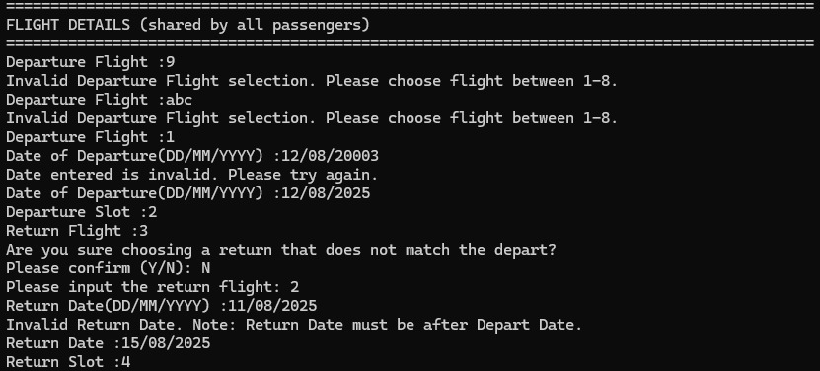
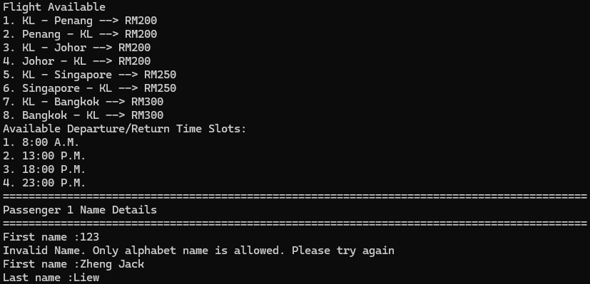
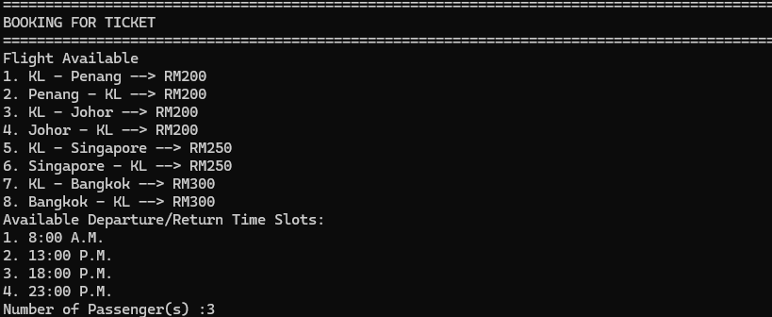

When a user is performing flight booking, they are required to select and enter the number of passengers, departure flight, departure date, departure slot, return flight, return date and return slot, and also the names of each passenger. Error will be informed when the departure or return flight choice is out of range and string or char is entered. Users are not allowed to type depart and return date in an incorrect format. Not only that, but the program will also inform users of invalid return date choice, for example return date cannot be earlier than the departure date. Passengers’ names are also validated, names cannot be in integer and must not be empty. After the booking is done, the program will show the user a summary of the booking to ease them for confirmation.

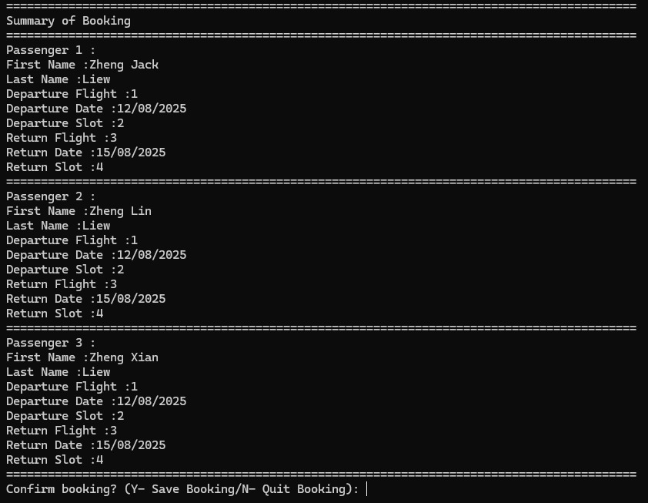

Display Summary of Booking
After confirming the booking, the booking details will be stored in the booking file. ( _Booking.txt)
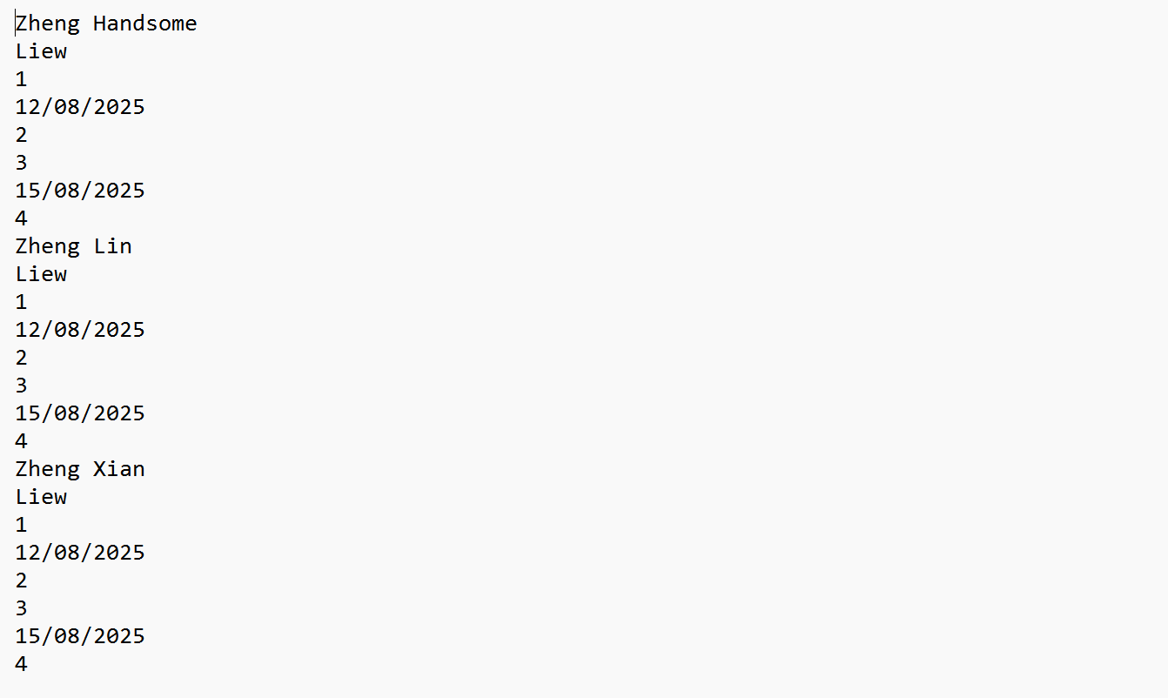
_Booking.txt
Test case 4 (Edit Booking)
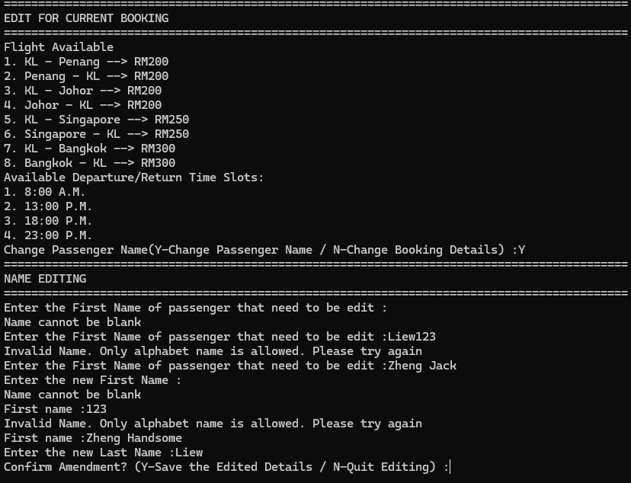

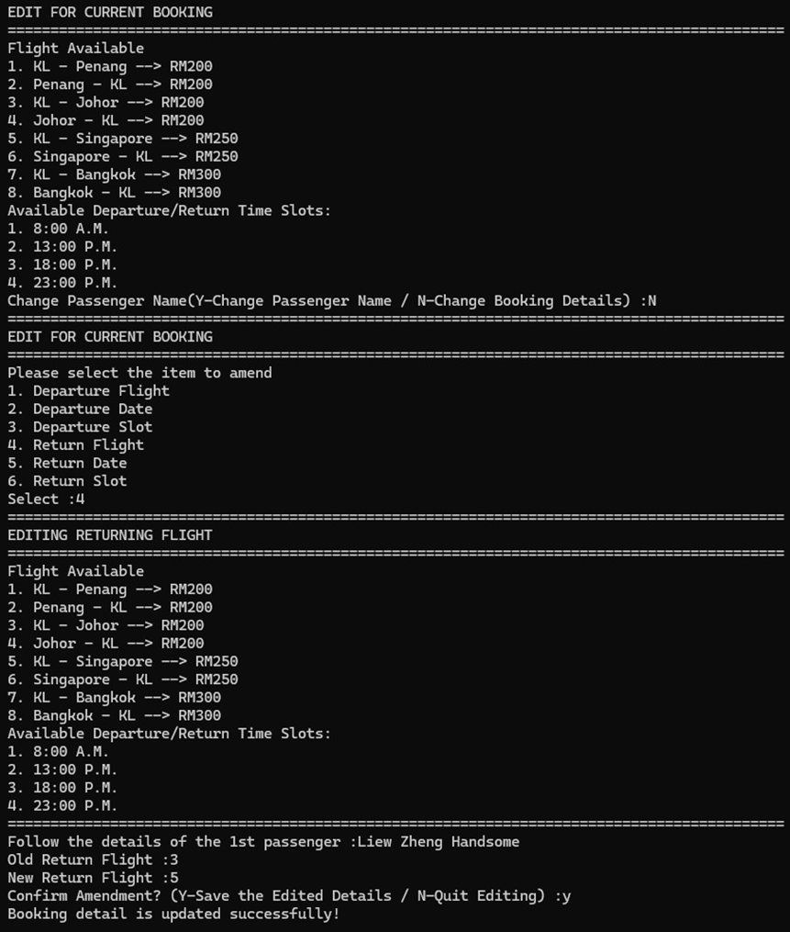

Display Editing Booking (Flight Editing)
By choosing 2, users are able to edit their booking details, such as departure flight, departure date, departure slot, return flight, return date, return slot and also passengers’ name. Similar to perform booking, the inputs (departure flight, departure date, departure slot, return flight, return date, return slot) will be validated so that the inputs are in the correct format. After confirmation, the edited details will update the booking details in the booking file as well as the total price and payment status in the paymentCheckIn file.
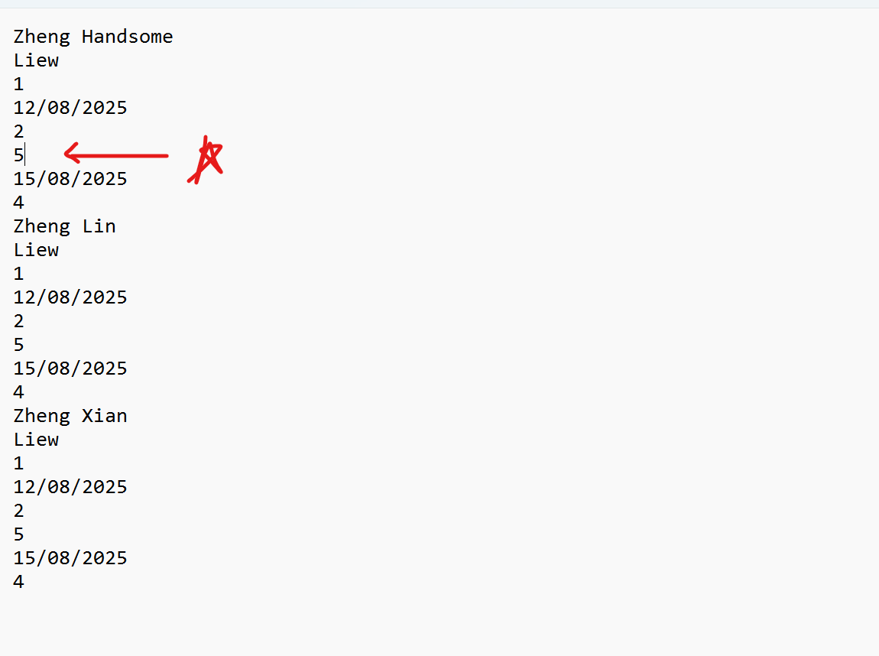
Booking file (Flight updated)

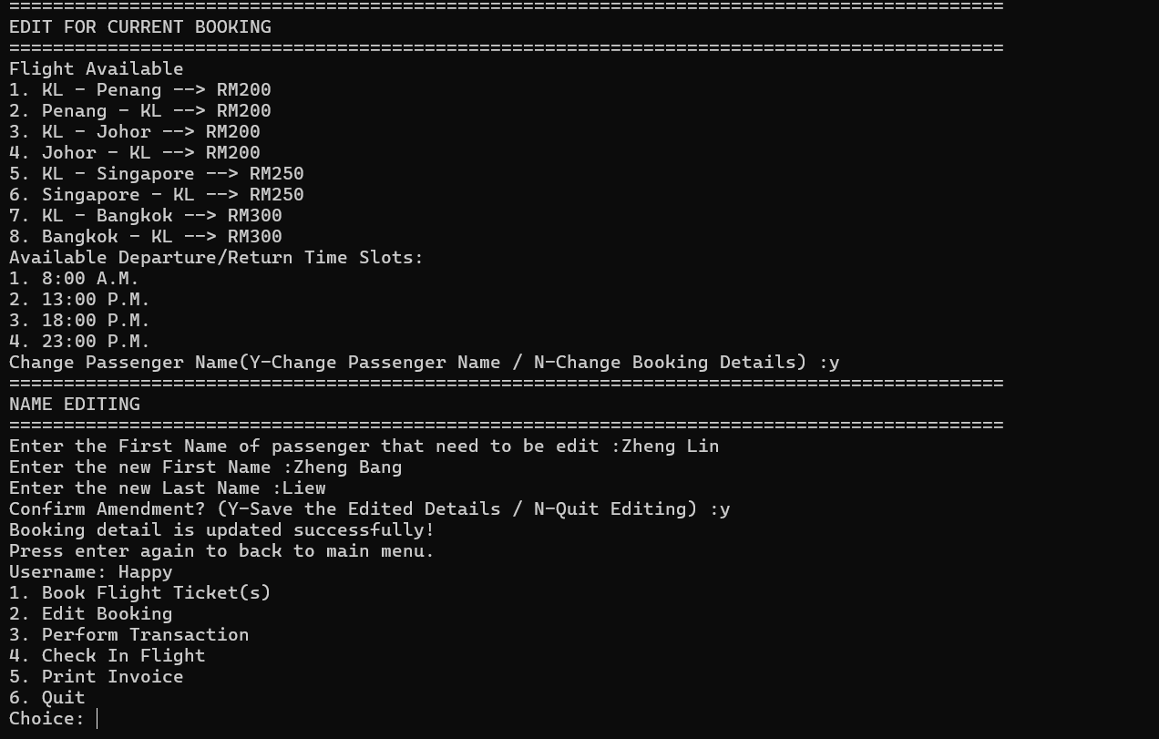
Display Editing Booking (Name edit)

User must type the first name of the passenger when performing name editing. The program will read the list of registered passengers’ names, when the first name is matched, the program will replace it with the new name. The booking file will also be updated.

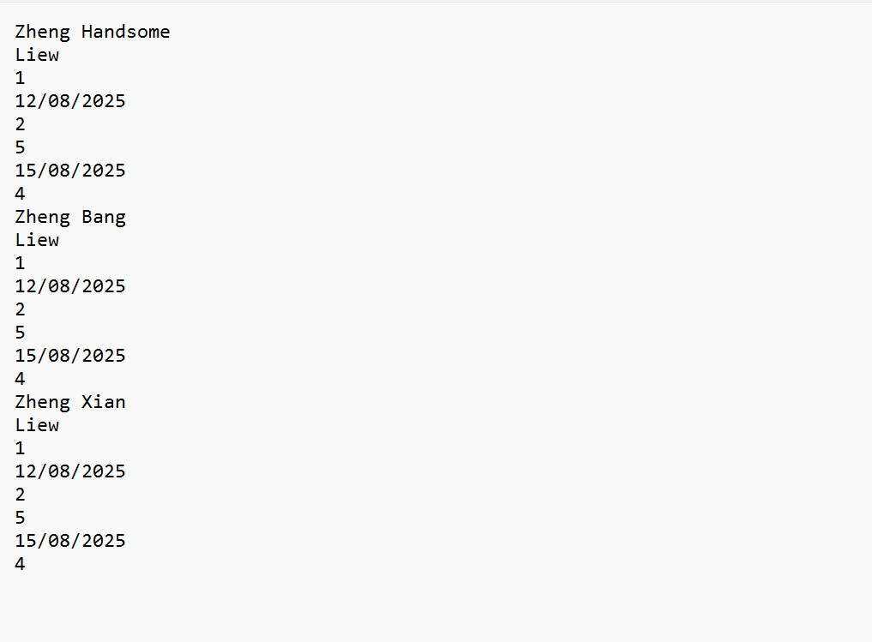
Booking File (Name updated)
Test case 5 (Perform Payment)
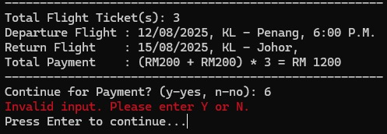

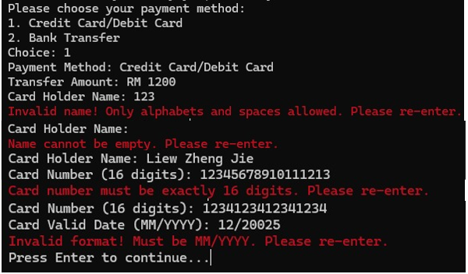

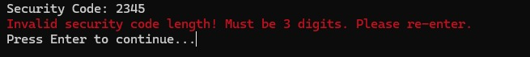
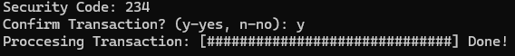

When the user chooses 3 to perform payment, users are required to choose the payment method, similar to the previous test cases, if the choice is out of range or a string input, the user will be informed to enter again. A warning display will be displayed when user entered empty value and integer for their card holder name, card number with more than or less than 16 digits, date with an incorrect card valid date format and security code with incorrect length and non-integer input. (when paying with credit card/debit card) Bank account number is also well-validated to ensure that the length and format is correct. (when paying with bank account) After payment is successful performed, payment status of the user is “Paid”. The user will be able to proceed with passenger details check in.

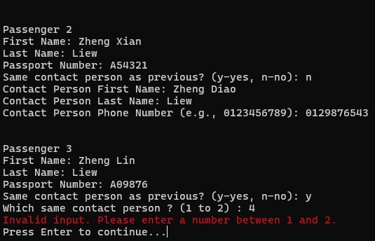
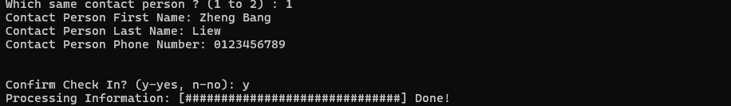
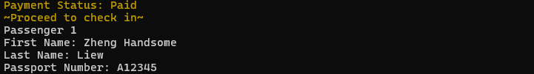
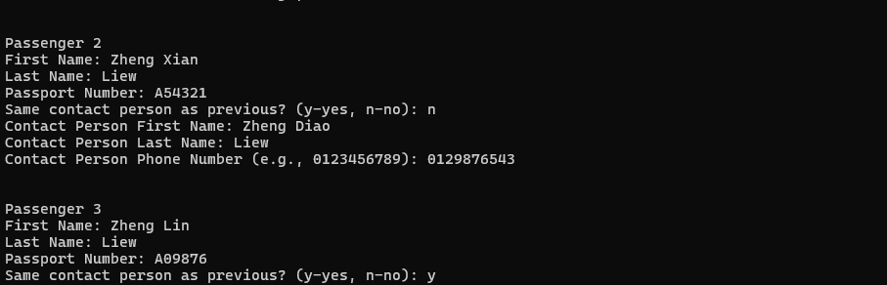
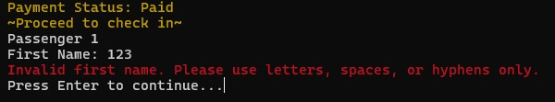
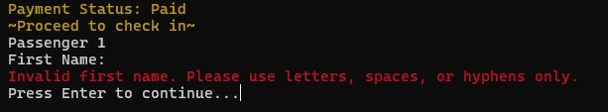
Test case 6 (Check In)

In check in section (choice = 4), the user is required to input each passenger details and contact person details. For passengers’ first name and last name, they are validated like the previous functions, only letters, spaces or hyphens are allowed. Passport numbers of passengers are required to be inserted in a format, it must be 6 to 9 characters, starting with a letter or digit and the rest are digits only. Other than that, the program also requires user to enter mobile numbers in Malaysian mobile number format. The program allows the user to use previous contact person information if any of the passengers share the same contact person, which could help user save time during check in process. The input must also be in the range of the number of previous passengers. After confirming check-in, the check-in details, which include passengers’ name, passport number, contact person name, contact person mobile number are stored in the payment check in file (_paymentCheckIn.txt). The check in status of the user will “Checked” too.
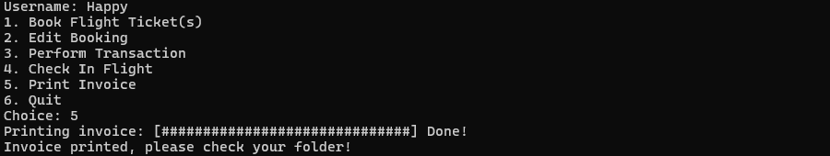
Test case 7 (Print Invoice)
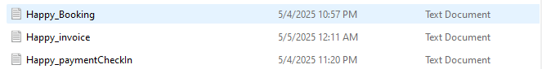
Program Display
Invoice Text File

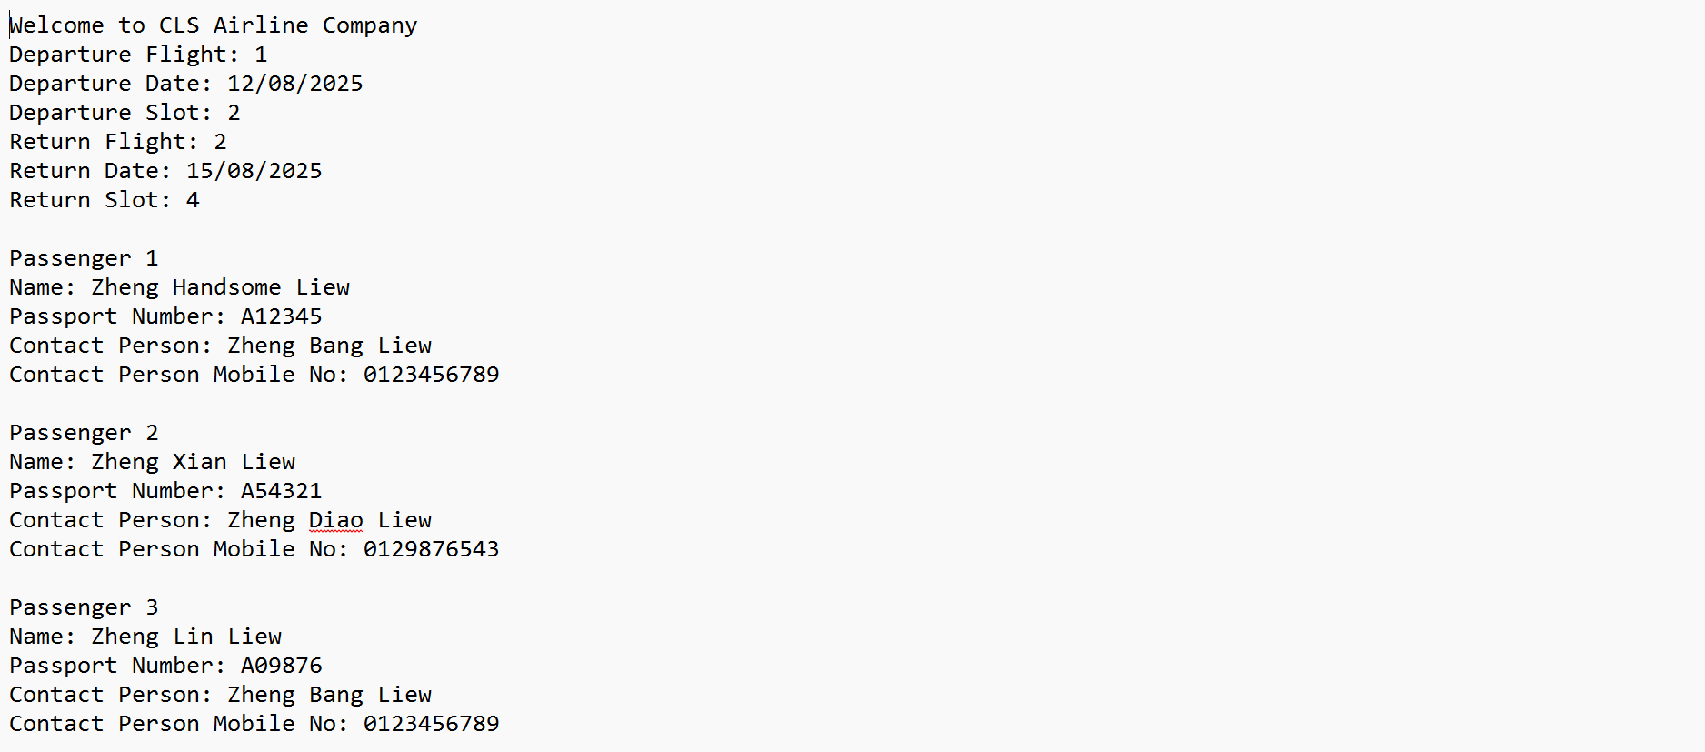
Users can print invoices by choosing 5 after booking, payment and flight check in are done. The program will display “Invoice printed, please check your folder” after the invoice is successfully printed. An invoice text file can be found in the folder.

Text file Content

In the invoice text file, all the passenger details are recorded and written in an orderly manner.

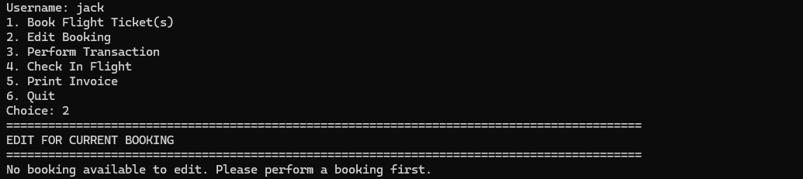
Test case 8 (Perform edit booking, perform payment, check in and invoice printing without booking, or payment, or check in)
Edit booking
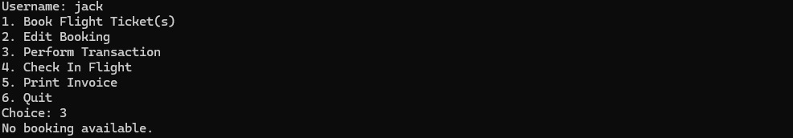
Perform Transaction
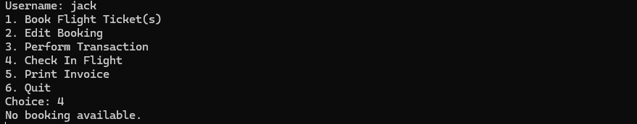

Check In Flight
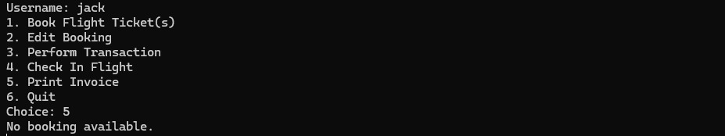
Print Invoice

If no booking is done, user cannot proceed to perform booking editing, payment, flight check in and invoice printing. While booking is done, but payment is not check in and invoice printing cannot be done because the payment status is “Not Paid”. When payment is done, but flight check in is not, user cannot proceed to print the invoice.

Source code
#include <iostream>
#include<iomanip>
#include <string>
#include <cctype>
#include <fstream>
#include <windows.h> //for decoration purpose
#include <chrono> //for decoration purpose
#include <thread> //for decoration purpose
using namespace std;
#define SIZE 20

//Define struct
struct FullName {
string first_name;
string last_name;
};
struct Registration {
FullName name;
string mobile_number;
string email;
string username;
string password;
};

struct BookingDetails {
FullName passenger_name;
int departureFlight;
string departureDate;
int departTime;
int returnFlight;
string returnDate;
int returnTime;
};
struct Passenger_Details {
FullName CheckIn_name;
string passport_num;
FullName contact_name;
string mobile_num;
};
struct CheckIn_Details {
double total_price;
string payment_status;
Passenger_Details passenger_flight[SIZE];
string checkIn_status;
};

string currentUser;
BookingDetails flight[SIZE];
int noTickets;

//Define function
void menu();
void FlightSchedule();
void registration();
void readUser(Registration users[SIZE], int& userCount);
void payment();
void checkIn(CheckIn_Details& details);
void readPaymentCheckIn(CheckIn_Details& details);
void performBooking();//Perform booking main function
void clearline(string message);//Decoration
void inputPassengerDetails(CheckIn_Details& details, int i);
void printInvoice(CheckIn_Details PassengerInfoList, BookingDetails BookingList[]);
void createPaymentCheckInInvoiceFile(int Num_Passengers);
void readBooking(BookingDetails flight[], int& noTickets);//read booking details from booking file
void editBooking(BookingDetails flight[], int noTickets);//Edit booking main function
void editMenu();//display menu for edit option
void showLoadingBar(string loading_message);
void showLoadingBarInvoice(string loading_message);
bool isAlphaOnly(const string& str);//Validation for only letters
bool isDigitsOnly(const string& str);//Validation for only digits
bool duplicateUsername(const string& username);//Validation for no duplicate username
bool strongPassword(const string& password);//Validation for correct password format
bool isAlphabetOnly(const string& name);//validation for name
bool validDate(const string& date);//validation to see if the date is in correct format
bool returnDate(const string& departDate, const string& returnDate);//validation to check if the return date is in future of depart date
bool isValidMobile(const string& mobile_num);
bool isValidPassportNumber(const string& passport_num);
bool isNotEmpty(const string& input);//validation for empty input for name
bool departBeforeReturn(const string& departDate, const string& returnDate);//validation to check if the depart date after editing is before the return date
bool isValidMobile(const string& mobile_num);
bool isValidPassportNumber(const string& passport_num);
bool isValidName(const string& name);
string validateCardHolder();
string validateSecurityCode();
string validateCardDate();
string validateCardNumber();
string validateBankAccountNumber();
string formattedWord(const string& input);//Format uppercase first letter and after space's letter
string removeSpaces(const string& input);
int login(Registration users[SIZE], int& userCount, string& currentUser);
int validReturnFlight(int departureFlight, int currentReturnFlight);//validation for flight to match destination
int getValidatedIntInput(const string& prompt, int min, int max);
char getYesNoInput(const string& promptMessage);
bool nameIsNotEmpty(const string& input);
void displayHeader();
void ticketBooking();
void editingHeader();
void paymentHeader();

int main() {
int userCount = 0;
int contRL = 1;
int cont = 1;
int choice;
Registration users[SIZE];
readUser(users, userCount);
do {
displayHeader();
cout << "\033[1;36m" << "==================================================================================================================================================" << "\033[0m" << endl;
cout << "\033[1;34m" << " Main menu " << "\033[0m" << endl;
cout << "\033[1;36m" << "==================================================================================================================================================\n" << "\033[0m" << endl;
cout << "\033[1;33m" << "1. Register New User" << "\t\t\t\t\t\t 2. Login" << "\t\t\t\t\t\t\t\t 3. Quit\n" << "\033[0m" << endl;
cout << "Choice: ";
//Input to register, login or quit
cin >> choice;
cin.ignore();

//Register New User
if (choice == 1) {
system("cls");
registration();
readUser(users, userCount);
displayHeader();
contRL = getValidatedIntInput("\033[1;36mDo you want to continue register/login? (1 - yes, 2 - no): \033[0m", 1, 2);

if (contRL == 2) {
cout << "\033[1;36m" << "\nThank you! Goodbye!" << "\033[0m" << endl;
return 0;
}
}
//Login
else if (choice == 2) {
int result;
readUser(users, userCount);
result = login(users, userCount, currentUser);

switch (result) {
//Username and password correct
case 1:
contRL = 0;
Sleep(100);
break;
//Username found but wrong password
case 2:
Sleep(500);
cout << "\033[1;31m" << "\nIncorrect password. Please try again.\n" << "\033[0m" << endl;
break;
//Password matches someone, but wrong username
case 3:
Sleep(500);
cout << "\033[1;31m" << "\nIncorrect username. Please try again.\n" << "\033[0m" << endl;
break;
//Both are not correct
case 4:
Sleep(500);
cout << "\033[1;31m" << "\nIncorrect username and password.Please try again.\n" << "\033[0m" << endl;
break;
}

//Input does not fit requirement and prompt user to register/login again
if (result == 2 || result == 3 || result == 4) {
cout << "\033[1;31m" << "If you have not registered, please register first!" << "\033[0m" << endl;
contRL = getValidatedIntInput("\033[1;36mDo you want to continue register/login? (1 - yes, 2 - no) : \033[0m", 1, 2);
//Quit the program
if (contRL == 2) {
clearline("Quitting the program. Goodbye!");
system("cls");
displayHeader();
cout << "\033[1;36m" << "\nThank you! Goodbye!" << "\033[0m" << endl;
return 0;
}
}
}
//Quit the program
else if (choice == 3) {
clearline("Quitting the program. Goodbye!");
system("cls");
displayHeader();
cout << "\033[1;36m" << "\nThank you! Goodbye!" << "\033[0m" << endl;
return 0;
}

//Validation check of input
else {
if (cin.fail()) {
cout << "\033[1;31m" << "Error: Invalid input. Please wait and try again." << "\033[0m" << endl;
cin.clear();
Sleep(1000);
string discard;
getline(cin, discard);
}
else {
cout << "\033[1;31m" << "Error: Invalid input. Please wait and try again" << "\033[0m" << endl;
Sleep(1000);
}
}
system("cls");
} while (contRL == 1);
do {
system("cls");
displayHeader();
cout << "\033[1;36m" << "==================================================================================================================================================" << "\033[0m" << endl;
cout << "\033[1;34m" << " JSJK Airline Company " << "\033[0m" << endl;
cout << "\033[1;36m" << "==================================================================================================================================================\n" << "\033[0m" << endl;
cout << "\033[1;32m" << " ~ Anyone ~ ~ Anywhere ~ ~ Anytime ~" << "\033[0m" << endl;
cout << "\033[1;36m" << "\nUsername: " << currentUser << "\n" << "\033[0m" << endl;
menu();
int select;
CheckIn_Details details;
readBooking(flight, noTickets);
readPaymentCheckIn(details);
select = getValidatedIntInput("Choice: ", 1, 6);
if (select == 1) {
system("cls");
displayHeader();
ticketBooking();
performBooking();
}
else if (select == 2) {
system("cls");
displayHeader();
editingHeader();
editBooking(flight, noTickets);
}
else if (select == 3) {
system("cls");
displayHeader();
paymentHeader();
if (!ifstream(currentUser + "_Booking.txt")) {
system("cls");
displayHeader();
cout << "\033[1;31m" << "\nNo booking available." << "\033[0m" << endl;
Sleep(2000);
}
else if (details.payment_status == "Paid") {
system("cls");
displayHeader();
cout << "\033[1;31m" << "\nYou have already paid." << "\033[0m" << endl;
Sleep(2000);
}
else {
payment();
}
}
else if (select == 4) {
system("cls");
displayHeader();
cout << "\033[1;36m" << "==================================================================================================================================================" << "\033[0m" << endl;
cout << "\033[1;34m" << " Check In Flight " << "\033[0m" << endl;
cout << "\033[1;36m" << "==================================================================================================================================================" << "\033[0m" << endl;
if (!ifstream(currentUser + "_Booking.txt")) {
system("cls");
displayHeader();
cout << "\033[1;31m" << "\nNo booking available." << "\033[0m" << endl;
Sleep(2000);
}
else if (details.payment_status == "Not Paid") {
system("cls");
displayHeader();
cout << "\033[1;31m" << "\nPayment not done yet. Please do your payment. " << "\033[0m" << endl;
Sleep(2000);

}
else if (details.checkIn_status == "Checked") {
system("cls");
displayHeader();
cout << "\033[1;31m" << "\nYou have Checked In" << "\033[0m" << endl;
Sleep(2000);
}
else {
checkIn(details);
}
}
else if (select == 5) {
system("cls");
displayHeader();
cout << "\033[1;36m" << "==================================================================================================================================================" << "\033[0m" << endl;
cout << "\033[1;34m" << " Print Invoice " << "\033[0m" << endl;
cout << "\033[1;36m" << "==================================================================================================================================================\n" << "\033[0m" << endl;
if (!ifstream(currentUser + "_Booking.txt")) {
system("cls");
displayHeader();
cout << "\033[1;31m" << "No booking available." << "\033[0m" << endl;
Sleep(2000);
}
else if (details.payment_status == "Not Paid") {
system("cls");
displayHeader();
cout << "\033[1;31m" << "Payment not done yet. Please do your payment. " << "\033[0m" << endl;
Sleep(2000);
}
else {
if (details.checkIn_status == "Not Check") {
system("cls");
displayHeader();
cout << "\033[1;31m" << "Check In Status: Not Checked\t\tPlease check in." << "\033[0m" << endl;
Sleep(2000);
}
else
printInvoice(details, flight);
}
}
else if (select == 6) {
clearline("Quitting the program. Goodbye!");
system("cls");
displayHeader();
cout << "\033[1;36m" << "\nThank you! Goodbye!" << "\033[0m" << endl;
cont = 0;
}
else
cout << "Not available" << endl;

if (select == 1 || select == 2) {
if (!ifstream(currentUser + "_Booking.txt")) {
}
else
createPaymentCheckInInvoiceFile(noTickets);
}
} while (cont == 1);
return 0;
}

//Decoration
void clearline(string message) {
for (int i = 0; i < 3; ++i) {
// Show message
cout << "\033[31m" << message << " \033[0m " << endl;
Sleep(150);

// Clear message by moving up and erasing the line
cout << "\033[A"; // Move cursor up one line
cout << "\033[K"; // Clear that line
Sleep(150);
}
cout << "\033[31m" << message << " \033[0m " << endl;
cout << "Press Enter to continue...";
string dummy;
getline(cin, dummy); //Avoid mistype of value before enter that will lead to error
for (int i = 0; i < 3; i++) {
cout << "\033[A";
cout << "\033[K";
}
}

//To ensure input is not empty
bool isNotEmpty(const string& input) {
for (char ch : input) {
if (!isspace(ch)) {
return true;
}
}
return false;
}

//To ensure input only in letters
bool isAlphaOnly(const string& str) {
for (char ch : str) {
if (!isalpha(ch) && ch != ' ')
return false;
}
return true;
}

//To enusre input string to have capitalized first letter after space and others in lower case
string formattedWord(const string& input) {
string result = input;
bool formatted_word = true;

for (char& ch : result) {
if (isalpha(ch)) {
if (formatted_word)
ch = toupper(ch);
else
ch = tolower(ch);
formatted_word = false;
}
else {
formatted_word = true;
}
}
return result;
}

//To ensure input only in numbers
bool isDigitsOnly(const string& str) {
for (char ch : str) {
if (!isdigit(ch))
return false;
}
return true;
}

//To ensure correct format of mobile number
bool isValidMobileNumber(const string& number) {
//To ensure input only in numbers
if (!isDigitsOnly(number)) return false;
//To ensure format of first two digits
if (number.substr(0, 2) != "01") return false;
//To ensure length of mobile number in a correct format
if (number.substr(0, 3) == "011") {
return number.length() == 11;
}
else {
return number.length() == 10;
}
}

//To ensure correct format of email
bool isValidEmail(const string& email) {
int condition1 = email.find('@');
int condition2 = email.find('.');
//The condition requires value before, between and after "@" and "."
return (condition1 > 0 &&
condition2 > condition1 + 1 &&
condition2 < email.length() - 1 &&
email.find(' ') == string::npos);
}

//To ensure no duplicate username entered
bool duplicateUsername(const string& username) {
ifstream file("user.txt");
string line;
int lineCount = 0;

while (getline(file, line)) {
lineCount++;

if (lineCount % 6 == 5 && line == username) {
return true;
}
}
return false;
}

//To ensure format of password
bool strongPassword(const string& password) {
if (password.length() < 8)
return false;
bool hasSpecial = false, hasUpper = false, hasDigit = false;

//The condition is need to have at least one uppercase letter, one digit and one special character
for (char ch : password) {
if (ispunct(ch)) hasSpecial = true;
else if (isupper(ch)) hasUpper = true;
else if (isdigit(ch)) hasDigit = true;
}

return hasUpper && hasDigit && hasSpecial;
}

//Registration part
void registration() {
//Declaration of varaiable
string first_name, last_name, mobile_number, email, username, password1, password2;
char confirm, choice;
int notEqualCount;

//do-while loop for register again
do {
displayHeader();
cout << "\033[1;36m" << "==================================================================================================================================================" << "\033[0m" << endl;
cout << "\033[1;34m" << " Registration " << "\033[0m" << endl;
cout << "\033[1;36m" << "==================================================================================================================================================\n" << "\033[0m" << endl;
cout << "\033[1;36m" << "Please key in details for registration: \n" << "\033[0m" << endl;
//do-while loop to ensure input to have no empty space and only in letters before the input being accepted.
do {
cout << "First name : ";
getline(cin, first_name);
//Show error when input is empty
if (!isNotEmpty(first_name)) {
clearline("Error: It cannot be blank. Please try again.");
continue;
}
//Show error when input not only in letters
if (!isAlphaOnly(first_name)) {
clearline("Error: Name must contain only letters. Please try again.");
continue;
}
break;
} while (!isNotEmpty(first_name) || !isAlphaOnly(first_name));
//Format the input
first_name = formattedWord(first_name);

//do-while loop to ensure input to have no empty space and only in letters before the input being accepted.
do {
cout << "Last name : ";
getline(cin, last_name);
//Show error when input is empty
if (!isNotEmpty(last_name)) {
clearline("Error: It cannot be blank. Please try again.");
continue;
}
//Show error when input not only in letters
if (!isAlphaOnly(last_name)) {
clearline("Error: Name must contain only letters. Please try again.");
continue;
}
break;
} while (!isNotEmpty(last_name) || !isAlphaOnly(last_name));
//Format the input
last_name = formattedWord(last_name);

//do-while loop to ensure input only in digits and correct format and length of mobile number before the input being accepted.
do {
cout << "Mobile number (01X..) : ";
getline(cin, mobile_number);
//Show error when input not only in letters
if (!isDigitsOnly(mobile_number)) {
clearline("Error: Mobile number must be only in digits.Please try again.");
continue;
}
//Correct format of mobile number
if (!isValidMobileNumber(mobile_number)) {
//Show error when input not start with "01"
if (mobile_number.substr(0, 2) != "01") {
clearline("Error: Mobile number must start with '01'. Please try again.");
continue;
}
//Show error when input with "011" not in 11 digits
if (mobile_number.substr(0, 3) == "011" && mobile_number.length() != 11) {
clearline("Error: 11 digits needed. Please try again.");
continue;
}
//Show error when input with other than "011" not in 10 digits
if (mobile_number.substr(0, 3) != "011" && mobile_number.length() != 10) {
clearline("Error: 10 digits needed. Please try again.");
continue;
}
break;
}
} while (!isDigitsOnly(mobile_number) || !isValidMobileNumber(mobile_number));

//do-while loop to ensure input to have no empty space and correct format of email before the input being accepted.
do {
cout << "Email(xx@xx.xx) : ";
getline(cin, email);
//Show error when input is empty
if (!isNotEmpty(email)) {
clearline("Error: It cannot be blank. Please try again.");
continue;
}
//Show error when input is not in the correct email format
if (!isValidEmail(email)) {
clearline("Error: Invalid email format. Please try again.");
continue;
}
break;
} while (!isNotEmpty(email) || !isValidEmail(email));

//do-while loop to ensure input to have no empty space, in letters only and no duplicate with existing username before the input being accepted.
do {
cout << "Enter your username : ";
getline(cin, username);
//Show error when input is empty
if (!isNotEmpty(username)) {
clearline("Error: It cannot be blank. Please try again.");
continue;
}
//Show error when input is not only in letters
if (!isAlphaOnly(username)) {
clearline("Error: Username must contain only letters. Please try again.");
continue;
}
//Show error when input is duplicate with existing username
if (duplicateUsername(username)) {
clearline("Error: The username is already exist. Please try entering another username.");
continue;
}
break;
} while (!isNotEmpty(username) || !isAlphaOnly(username) || duplicateUsername(username));

//do-while loop to make sure the re-enter password must be less than 3 failed attempts.
do {
//do-while loop to ensure password is strong before the input being accepted.
do {
cout << "Password (At least 8 characters, including 1 symbol, 1 uppercase letter, and 1 number) : ";
getline(cin, password1);
//Show error when input do not meet the condition to have a strong password
if (!strongPassword(password1)) {
clearline("Error: Invalid password format. Please try again.");
}
} while (!strongPassword(password1));

notEqualCount = 0;
//do-while loop to ensure both password input is the same and re-enter password after mismatch over 3 attempts
do {
cout << "Re-enter your password : ";
getline(cin, password2);
//Show error when input not same with the previous password input
if (password1 != password2) {
notEqualCount++;
clearline("Error: Both passwords do not match. Please try again.");
//Show erroe when input fail over 3 attempts
if (notEqualCount == 3) {
clearline("Error: Too many failed attempts. Please re-enter a new password.");
break;
}
}

} while (password1 != password2 && notEqualCount < 3);

} while (notEqualCount == 3);
cout << endl;
//do-while loop to ensure registration confirmed
do {
cout << "\033[1;36m" << "Confirm to register? (y - yes, n - no): " << "\033[0m";
cin >> confirm;
cin.ignore();

//Confirm to register and save in txt file
if (confirm == 'y' || confirm == 'Y') {

clearline("Registration done!");
ofstream myfile;
myfile.open("user.txt", ios::app);
if (myfile.is_open()) {
myfile << first_name << endl;
myfile << last_name << endl;
myfile << mobile_number << endl;
myfile << email << endl;
myfile << username << endl;
myfile << password2 << endl;

myfile.close();
}
else {
}
myfile.close();
}
//Reject to register
else if (confirm == 'n' || confirm == 'N') {
clearline("Registration cancelled. Please register again.");
system("cls");

//do-while loop to ask user to register again or quit the program
do {
displayHeader();
cout << "\033[1;36m" << "Do you want to? (R - Register again, Q - Quit): " << "\033[0m";
//Input whether need to register again or quit
cin >> choice;
cin.ignore();
//Quit the program
if (choice == 'q' || choice == 'Q') {
clearline("Quitting...");
system("cls");
return;
}
//Register again
else if (choice == 'r' || choice == 'R') {
clearline("Connecting back to registration page...");
break;
}
//Show error when invalid input
else {
clearline("Error: Invalid choice. Please try again.");
system("cls");
}
} while (choice != 'q' && choice != 'Q' && choice != 'r' && choice != 'R');
}
//Show error when invalid input
else {
clearline("Error: Invalid choice. Please try again.");
}
} while (confirm != 'y' && confirm != 'Y' && confirm != 'n' && confirm != 'N');

system("cls");
} while (confirm == 'n' || confirm == 'N');
}

//Function to read the user details that stored in txt file
void readUser(Registration users[SIZE], int& userCount) {
string line;
ifstream myfile("user.txt");
userCount = 0;

if (myfile.is_open()) {
while (getline(myfile, users[userCount].name.first_name) &&
getline(myfile, users[userCount].name.last_name) &&
getline(myfile, users[userCount].mobile_number) &&
getline(myfile, users[userCount].email) &&
getline(myfile, users[userCount].username) &&
getline(myfile, users[userCount].password)) {
userCount++;
}
myfile.close();
}
else {
}
}

//Function to ensure the input username and password are matching
int login(Registration users[SIZE], int& userCount, string& currentUser) {
string inputUserName, inputPassword;
system("cls");
displayHeader();
cout << "\033[1;36m" << "==================================================================================================================================================" << "\033[0m" << endl;
cout << "\033[1;34m" << " Login " << "\033[0m" << endl;
cout << "\033[1;36m" << "==================================================================================================================================================\n" << "\033[0m" << endl;
cout << "Enter your username to login: ";
getline(cin, inputUserName);
cout << "Enter your password to login: ";
getline(cin, inputPassword);
bool usernameFound = false;
bool passwordCorrect = false;
for (int i = 0; i < userCount; ++i) {
if (users[i].username == inputUserName && users[i].password == inputPassword) {
currentUser = inputUserName;
cout << "\033[1;31m" << "\nLogin Successfully!" << "\033[0m" << endl;
cout << "\033[1;36m" << "\nWelcome, " << currentUser << "!" << "\033[0m" << endl;
clearline("Redirecting to the login page...");
return 1; //Username and password correct
}
if (users[i].username == inputUserName) {
usernameFound = true;
}
if (users[i].password == inputPassword) {
passwordCorrect = true;
}
}
//Username found but wrong password
if (usernameFound) return 2;
//Password matches someone, but wrong username
if (passwordCorrect) return 3;
//Both are not correct
return 4;
}

void editBooking(BookingDetails flight[], int noTickets) {
if (noTickets == 0) {//if booking file not found
cout << "No booking available to edit. Please perform a booking first." << endl;
Sleep(2000);
system("cls");
}
else {
char changeName, saveEdit;
int editChoice;
bool edited = false; // track if any changes were made

FlightSchedule();
cout << "Change Passenger Name(Y-Change Passenger Name / N-Change Booking Details) : ";
cin >> changeName;
while (cin.fail() || (changeName != 'y' && changeName != 'Y' && changeName != 'n' && changeName != 'N')) {//if the user want to change the passenger name
cin.clear();
cin.ignore(1000, '\n');
clearline("Operation is invalid. Please try again.");
cout << "Change Passenger Name(Y-Change Passenger Name / N-Change Booking Details) : ";
cin >> changeName;
}
cin.ignore();

if (changeName == 'Y' || changeName == 'y') {
system("cls");
displayHeader();
editingHeader();
cout << "\033[1;36m" << "--------------------------------------------------------------------------------------------------------------------------------------------------" << "\033[0m" << endl;
cout << "\033[1;34m" << " Change Passenger Name " << "\033[0m" << endl;
cout << "\033[1;36m" << "--------------------------------------------------------------------------------------------------------------------------------------------------\n" << "\033[0m" << endl;
string searchname;
cout << "Enter the First Name of passenger that need to be edit : ";
getline(cin, searchname);
while (cin.fail() || !isAlphabetOnly(removeSpaces(searchname)) || !nameIsNotEmpty(searchname))//Validation of Name(Alphabet only)
{
if (!nameIsNotEmpty(searchname))//if input is blank, show error
clearline("Name cannot be blank");
else if (!isAlphabetOnly(removeSpaces(searchname)))//name only alphabet is allowed
clearline("Invalid Name. Only alphabet name is allowed. Please try again ");//show error when invalid
else
clearline("Invalid Name. Please try again.");
cout << "Enter the First Name of passenger that need to be edit : ";
getline(cin, searchname);
}
bool found = false;//predefined the indicator for name matching in the file to see if the user exist in booking
for (int i = 0; i < noTickets; i++) {
if (flight[i].passenger_name.first_name == searchname) {
//New First name input
cout << "Enter the new First Name : ";
getline(cin, flight[i].passenger_name.first_name);
while (cin.fail() || !isAlphabetOnly(removeSpaces(flight[i].passenger_name.first_name)) || !nameIsNotEmpty(flight[i].passenger_name.first_name))//Validation of Name(Alphabet only)
{
if (!nameIsNotEmpty(flight[i].passenger_name.first_name))//if input blank, error
clearline("Name cannot be blank");
else if (!isAlphabetOnly(removeSpaces(flight[i].passenger_name.first_name)))//if name is not alphabet only
clearline("Invalid Name. Only alphabet name is allowed. Please try again ");//show error when invalid
else
clearline("Invalid Name. Please try again.");
cout << "Enter the new First Name : ";
getline(cin, flight[i].passenger_name.first_name);
}
//New Last name input
cout << "Enter the new Last Name : ";
getline(cin, flight[i].passenger_name.last_name);
while (cin.fail() || !isAlphabetOnly(removeSpaces(flight[i].passenger_name.last_name)) || !nameIsNotEmpty(flight[i].passenger_name.last_name))//Validation of Name(Alphabet only)
{
if (!nameIsNotEmpty(flight[i].passenger_name.last_name))//if input blank,error
clearline("Name cannot be blank");
else if (!isAlphabetOnly(removeSpaces(flight[i].passenger_name.last_name)))//if not alphabet only, error
clearline("Invalid Name. Only alphabet name is allowed. Please try again.");//show error when invalid
else
clearline("Invalid Name. Please try again.");
cout << "Enter the new Last Name : ";
getline(cin, flight[i].passenger_name.last_name);
}
found = true;//when user found,let user to edit
edited = true; // indicator for change made
break;
}
}
if (!found) {//if user not found in booking file
cout << "Passenger does not exist in Booking File. Please perform a booking first." << endl;//show error because no booking
cout << "Press enter again to back to main menu." << endl;
system("pause");
system("cls");
return; // exit early
}
}
else if (changeName == 'N' || changeName == 'n') {//if user dont want to edit booking details
system("cls");
displayHeader();
editingHeader();
cout << "\033[1;36m" << "--------------------------------------------------------------------------------------------------------------------------------------------------" << "\033[0m" << endl;
cout << "\033[1;34m" << " Change Booking Details " << "\033[0m" << endl;
cout << "\033[1;36m" << "--------------------------------------------------------------------------------------------------------------------------------------------------\n" << "\033[0m" << endl;
editMenu();
cin >> editChoice;
cin.ignore();
cin.clear();
switch (editChoice) {
case 1://edit depart flight
system("cls");
displayHeader();
editingHeader();
cout << "\033[1;36m" << "--------------------------------------------------------------------------------------------------------------------------------------------------" << "\033[0m" << endl;
cout << "\033[1;34m" << " Editing Depature Flight " << "\033[0m" << endl;
cout << "\033[1;36m" << "--------------------------------------------------------------------------------------------------------------------------------------------------\n" << "\033[0m" << endl;
FlightSchedule();
cout << "\033[1;36m" << "==================================================================================================================================================\n" << "\033[0m" << endl;
cout << "Follow the details of the 1st passenger : " << flight[0].passenger_name.last_name << " " << flight[0].passenger_name.first_name << endl;
cout << "\nOld Departure Flight : " << flight[0].departureFlight << endl;
cout << "New Departure Flight : ";
cin >> flight[0].departureFlight;
while (cin.fail() || flight[0].departureFlight < 1 || flight[0].departureFlight > 8) {//validation for depart flight
cin.clear();
cin.ignore(1000, '\n');
clearline("Invalid flight. Choose between 1 to 8");//if flight not in range 1-8, show error
cout << "New Departure Flight : ";
cin >> flight[0].departureFlight;
}
cin.ignore();
cin.clear();
edited = true;//indicator to show edit has been made
break;

case 2://edit depart date
system("cls");
displayHeader();
editingHeader();
cout << "\033[1;36m" << "--------------------------------------------------------------------------------------------------------------------------------------------------" << "\033[0m" << endl;
cout << "\033[1;34m" << " Editing Depature Date " << "\033[0m" << endl;
cout << "\033[1;36m" << "--------------------------------------------------------------------------------------------------------------------------------------------------\n" << "\033[0m" << endl;
FlightSchedule();
cout << "\033[1;36m" << "==================================================================================================================================================\n" << "\033[0m" << endl;
cout << "Follow the details of the 1st passenger : " << flight[0].passenger_name.last_name << " " << flight[0].passenger_name.first_name << endl;
cout << "\nOld Departure Date : " << flight[0].departureDate << endl;
cout << "New departure Date : ";
getline(cin, flight[0].departureDate);
while (!departBeforeReturn(flight[0].departureDate, flight[0].returnDate) || !isNotEmpty(flight[0].departureDate)) {//validation for depart date edit
if (!isNotEmpty(flight[0].departureDate))//if input is blank
clearline("Date must not be empty");//show error
else if (!departBeforeReturn(flight[0].departureDate, flight[0].returnDate))//if depart date edit is after the return date
clearline("Invalid Date or Depart Date must be in past of Return Date.");//show date error
else
clearline("Invalid Depart Date");
cout << "New departure Date : ";
getline(cin, flight[0].departureDate);
}
edited = true;//indicator that edit has been made
break;

case 3://edit depart time slot
system("cls");
displayHeader();
editingHeader();
cout << "\033[1;36m" << "--------------------------------------------------------------------------------------------------------------------------------------------------" << "\033[0m" << endl;
cout << "\033[1;34m" << " Editing Depature Time Slot " << "\033[0m" << endl;
cout << "\033[1;36m" << "--------------------------------------------------------------------------------------------------------------------------------------------------\n" << "\033[0m" << endl;
FlightSchedule();
cout << "\033[1;36m" << "==================================================================================================================================================\n" << "\033[0m" << endl;
cout << "Follow the details of the 1st passenger : " << flight[0].passenger_name.last_name << " " << flight[0].passenger_name.first_name << endl;
cout << "\nOld Departure Slot : " << flight[0].departTime << endl;
cout << "New Departure Slot : ";
cin >> flight[0].departTime;
while (cin.fail() || flight[0].departTime < 1 || flight[0].departTime > 4) {//validation to check if the depart slot is in range 1-4
cin.clear();
cin.ignore(1000, '\n');
clearline("Invalid Slot.Choose between 1 to 4");//error show when the slot selected is not in range
cout << "New Departure Slot : ";
cin >> flight[0].departTime;
}
cin.ignore();
edited = true;//indicator for edit has been made
break;

case 4://edit return flight
system("cls");
displayHeader();
editingHeader();
cout << "\033[1;36m" << "--------------------------------------------------------------------------------------------------------------------------------------------------" << "\033[0m" << endl;
cout << "\033[1;34m" << " Editing Return Date " << "\033[0m" << endl;
cout << "\033[1;36m" << "--------------------------------------------------------------------------------------------------------------------------------------------------\n" << "\033[0m" << endl;
FlightSchedule();
cout << "\033[1;36m" << "==================================================================================================================================================\n" << "\033[0m" << endl;
cout << "Follow the details of the 1st passenger : " << flight[0].passenger_name.last_name << " " << flight[0].passenger_name.first_name << endl;
cout << "\nOld Return Flight : " << flight[0].returnFlight << endl;
cout << "New Return Flight : ";
cin >> flight[0].returnFlight;
while (cin.fail() || flight[0].returnFlight < 1 || flight[0].returnFlight > 8) {//validation for the input see if it in range 1-8
cin.clear();
cin.ignore(1000, '\n');
clearline("Invalid flight. Choose between 1 to 8");//show error when flight not in range
cout << "New Return Flight : ";
cin >> flight[0].returnFlight;
}
cin.ignore();
edited = true;//indicator that edit has been made
break;

case 5://edit return date
system("cls");
displayHeader();
editingHeader();
cout << "\033[1;36m" << "--------------------------------------------------------------------------------------------------------------------------------------------------" << "\033[0m" << endl;
cout << "\033[1;34m" << " Editing Return Flight " << "\033[0m" << endl;
cout << "\033[1;36m" << "--------------------------------------------------------------------------------------------------------------------------------------------------\n" << "\033[0m" << endl;
FlightSchedule();
cout << "\033[1;36m" << "==================================================================================================================================================\n" << "\033[0m" << endl;
cout << "Follow the details of the 1st passenger : " << flight[0].passenger_name.last_name << " " << flight[0].passenger_name.first_name << endl;
cout << "\nOld Return Date : " << flight[0].returnDate << endl;
cout << "New Return Date : ";
getline(cin, flight[0].returnDate);
while (!returnDate(flight[0].departureDate, flight[0].returnDate) || !isNotEmpty(flight[0].returnDate)) {//validation for return date edited
if (!isNotEmpty(flight[0].returnDate))//validate if the input is blank
clearline("Return Date must not be Empty.");//show error if the return date is blank
else if (!returnDate(flight[0].departureDate, flight[0].returnDate))//validate if the return date is before the depart date
clearline("Invalid Return Date or Return Date must be in future of Depart Date.");//show error if the return date is before depart date
else
clearline("Invalid Return Date.");
cout << "New Return Date : ";
getline(cin, flight[0].returnDate);
}
edited = true;//indicator to show edit has been made
break;

case 6://edit return time slot
system("cls");
displayHeader();
editingHeader();
cout << "\033[1;36m" << "--------------------------------------------------------------------------------------------------------------------------------------------------" << "\033[0m" << endl;
cout << "\033[1;34m" << " Editing Return Time Slot " << "\033[0m" << endl;
cout << "\033[1;36m" << "--------------------------------------------------------------------------------------------------------------------------------------------------\n" << "\033[0m" << endl;
FlightSchedule();
cout << "\033[1;36m" << "==================================================================================================================================================\n" << "\033[0m" << endl;
cout << "Follow the details of the 1st passenger : " << flight[0].passenger_name.last_name << " " << flight[0].passenger_name.first_name << endl;
cout << "\nOld Return Slot : " << flight[0].returnTime << endl;
cout << "New Return Slot : ";
cin >> flight[0].returnTime;
while (cin.fail() || flight[0].returnTime < 1 || flight[0].returnTime > 4) {//validate to see if the return timeslot is in range 1-4
cin.clear();
cin.ignore(1000, '\n');
clearline("Invalid Slot. Choose between 1 to 4");//show error if slot is out of range
cout << "New Return Slot : ";
cin >> flight[0].returnTime;
}
cin.ignore();
edited = true;//indicator to show edit has been made
break;

default:
clearline("Invalid Choice. You will be take back to the homepage...");//if the user input number that out of range, error show
break;
}
}

// Only save if something was edited
if (edited) {//if edit made, ask if the user want to confirm and save
cout << "\nConfirm Amendment? (Y-Save the Edited Details / N-Quit Editing) : ";
cin >> saveEdit;
cin.ignore();
while (cin.fail() || (saveEdit != 'y' && saveEdit != 'Y' && saveEdit != 'n' && saveEdit != 'N')) {//if the user input is other from y or n
cin.clear();
cin.ignore(1000, '\n');
clearline("Invalid input.Only Y or N is allowed.");//error show for invalid input
cout << "Confirm Amendment? (Y-Save the Edited Details / N-Quit Editing) : " << endl;
cin >> saveEdit;
}

if (saveEdit == 'Y' || saveEdit == 'y') {//if yes, save the edited details to file
ofstream myfile(currentUser + "_Booking.txt");
for (int i = 0; i < noTickets; i++) {
myfile << flight[i].passenger_name.first_name << endl;
myfile << flight[i].passenger_name.last_name << endl;
myfile << flight[0].departureFlight << endl;
myfile << flight[0].departureDate << endl;
myfile << flight[0].departTime << endl;
myfile << flight[0].returnFlight << endl;
myfile << flight[0].returnDate << endl;
myfile << flight[0].returnTime << endl;
}
myfile.close();
cout << endl;
cout << "\033[1;31m" << "Booking detail is updated successfully!" << "\033[0m\n" << endl;
cout << "Press enter again to back to main menu." << endl;
system("pause");
system("cls");
}
else if (saveEdit == 'N' || saveEdit == 'n') {//if dont want to save, edit will not be save to file, and exit from the edit menu
cout << "\033[1;31m" << "Edit has been cancelled." << "\033[0m\n" << endl;
cout << "Press enter again to back to main menu." << endl;
system("pause");
system("cls");
}
}
}
}

void readBooking(BookingDetails flight[], int& noTickets) {
ifstream myfile;
myfile.open(currentUser + "_Booking.txt");

if (myfile.fail()) {//if file is not found
}
else {
noTickets = 0;//indicator when booking file is not found to be use in edit booking
while (!myfile.eof()) {//while file is found, read the booking details of user
getline(myfile, flight[noTickets].passenger_name.first_name);
if (flight[noTickets].passenger_name.first_name == "")
break;
getline(myfile, flight[noTickets].passenger_name.last_name);
myfile >> flight[noTickets].departureFlight;
myfile.ignore();
getline(myfile, flight[noTickets].departureDate);
myfile >> flight[noTickets].departTime;
myfile.ignore();
myfile >> flight[noTickets].returnFlight;
myfile.ignore();
getline(myfile, flight[noTickets].returnDate);
myfile >> flight[noTickets].returnTime;
myfile.ignore();
noTickets++;
}
}
myfile.close();
}

//Choice 1 function
void performBooking()
{
char confirmBooking;
const int maxTickets = 20;

FlightSchedule();
cout << "Number of Passenger(s): ";
cin >> noTickets;
while (cin.fail() || noTickets <= 0 || noTickets > maxTickets) {
cin.clear();
cin.ignore(1000, '\n');
clearline("Invalid Number of Passenger! Please try again.");
cout << "Number of Passenger(s): ";
cin >> noTickets;
}
cin.ignore();
system("cls");
displayHeader();
ticketBooking();
FlightSchedule();

// Shared flight details input once
int sharedDepartureFlight, sharedReturnFlight, sharedDepartTime, sharedReturnTime;
string sharedDepartureDate, sharedReturnDate;

cout << "\033[1;36m" << "--------------------------------------------------------------------------------------------------------------------------------------------------" << "\033[0m" << endl;
cout << "\033[1;34m" << " Flight Details (Shared by ALL Passengers) " << "\033[0m" << endl;
cout << "\033[1;36m" << "--------------------------------------------------------------------------------------------------------------------------------------------------\n" << "\033[0m" << endl;

// Departure Flight
cout << "\033[1;36m" << "Number of passenger(s): " << noTickets << "\033[0m\n" << endl;
cout << "Departure Flight : ";
cin >> sharedDepartureFlight;
while (cin.fail() || sharedDepartureFlight <= 0 || sharedDepartureFlight > 8) {
cin.clear();
cin.ignore(1000, '\n');
clearline("Invalid Departure Flight selection. Please choose flight between 1-8.");
cout << "Departure Flight : ";
cin >> sharedDepartureFlight;
}
cin.ignore();

// Departure Date
cout << "Date of Departure(DD/MM/YYYY) : ";
getline(cin, sharedDepartureDate);
while (!validDate(sharedDepartureDate) || !isNotEmpty(sharedDepartureDate)) {
if (!isNotEmpty(sharedDepartureDate))
clearline("Depart Date cannot be empty.");
else
clearline("Date entered is invalid. Please try again.");
cout << "Date of Departure(DD/MM/YYYY) : ";
getline(cin, sharedDepartureDate);
}

// Departure Slot
cout << "Departure Slot : ";
cin >> sharedDepartTime;
while (cin.fail() || sharedDepartTime <= 0 || sharedDepartTime > 4) {
cin.clear();
cin.ignore(1000, '\n');
clearline("Invalid Selection of Time Slot. Please try again.");
cout << "Departure Slot : ";
cin >> sharedDepartTime;
}
cin.ignore();

// Return Flight
cout << "Return Flight : ";
cin >> sharedReturnFlight;
while (cin.fail() || sharedReturnFlight <= 0 || sharedReturnFlight > 8) {
cin.clear();
cin.ignore(1000, '\n');
clearline("Invalid Return Flight. Please choose flight 1-8");
cout << "Return Flight : ";
cin >> sharedReturnFlight;
}
while (!validReturnFlight(sharedDepartureFlight, sharedReturnFlight)) {
cout << "Invalid Return Flight (does not match destination). Please choose again (1-8): ";
cin >> sharedReturnFlight;
}
cin.ignore();

// Return Date
cout << "Return Date(DD/MM/YYYY) : ";
getline(cin, sharedReturnDate);
while (!returnDate(sharedDepartureDate, sharedReturnDate) || !isNotEmpty(sharedReturnDate)) {
if (!isNotEmpty(sharedReturnDate))
clearline("Return Date must not be empty.");
else
clearline("Invalid Return Date. Note: Return Date must be after Depart Date.");
cout << "Return Date(DD/MM/YYYY) : ";
getline(cin, sharedReturnDate);
}

// Return Slot
cout << "Return Slot : ";
cin >> sharedReturnTime;
while (cin.fail() || sharedReturnTime <= 0 || sharedReturnTime > 4) {
cin.clear();
cin.ignore(1000, '\n');
clearline("Invalid Return Slot. Please Choose slot between 1-4.");
cout << "Return Slot : ";
cin >> sharedReturnTime;
}
cin.ignore();

// Individual passenger name input
for (int i = 0; i < noTickets; i++) {
system("cls");
displayHeader();
ticketBooking();
cout << "\033[1;36m" << "--------------------------------------------------------------------------------------------------------------------------------------------------" << "\033[0m" << endl;
cout << "\033[1;34m" << " Passenger " << i + 1 << " Name Details " << "\033[0m" << endl;
cout << "\033[1;36m" << "--------------------------------------------------------------------------------------------------------------------------------------------------\n" << "\033[0m" << endl;

// First name
cout << "First name : ";
getline(cin, flight[i].passenger_name.first_name);
while (cin.fail() || !isAlphabetOnly(removeSpaces(flight[i].passenger_name.first_name)) || !nameIsNotEmpty(flight[i].passenger_name.first_name)) {
if (!nameIsNotEmpty(flight[i].passenger_name.first_name))
cout << "Name cannot be blank" << endl;
else if (!isAlphabetOnly(removeSpaces(flight[i].passenger_name.first_name)))
cout << "Invalid Name. Only alphabet name is allowed. Please try again" << endl;
else
cout << "Invalid Name. Please try again." << endl;
cout << "First name :";
getline(cin, flight[i].passenger_name.first_name);
}

// Last name
cout << "Last name : ";
getline(cin, flight[i].passenger_name.last_name);
while (cin.fail() || !isAlphabetOnly(removeSpaces(flight[i].passenger_name.last_name)) || !nameIsNotEmpty(flight[i].passenger_name.last_name)) {
if (!nameIsNotEmpty(flight[i].passenger_name.last_name))
cout << "Name cannot be blank" << endl;
else if (!isAlphabetOnly(removeSpaces(flight[i].passenger_name.last_name)))
cout << "Invalid Name. Only alphabet name is allowed. Please try again" << endl;
else
cout << "Invalid Name. Please try again." << endl;
cout << "Last name : ";
getline(cin, flight[i].passenger_name.last_name);
}

// all passenger shared flight details
flight[i].departureFlight = sharedDepartureFlight;
flight[i].departureDate = sharedDepartureDate;
flight[i].departTime = sharedDepartTime;
flight[i].returnFlight = sharedReturnFlight;
flight[i].returnDate = sharedReturnDate;
flight[i].returnTime = sharedReturnTime;
}

// Summary display
system("cls");
displayHeader();
ticketBooking();
cout << "\033[1;36m" << "--------------------------------------------------------------------------------------------------------------------------------------------------" << "\033[0m" << endl;
cout << "\033[1;34m" << " Summary of Booking " << "\033[0m" << endl;
cout << "\033[1;36m" << "--------------------------------------------------------------------------------------------------------------------------------------------------\n" << "\033[0m" << endl;
FlightSchedule();
cout << "\033[1;36m" << "==================================================================================================================================================\n" << "\033[0m" << endl;

for (int i = 0; i < noTickets; i++) {
cout << "\033[1;33m" << "Passenger " << i + 1 << " :" << "\033[0m\n" << endl;
cout << "First Name : " << flight[i].passenger_name.first_name << endl;
cout << "Last Name : " << flight[i].passenger_name.last_name << endl;
cout << "Departure Flight : " << flight[i].departureFlight << endl;
cout << "Departure Date : " << flight[i].departureDate << endl;
cout << "Departure Slot : " << flight[i].departTime << endl;
cout << "Return Flight : " << flight[i].returnFlight << endl;
cout << "Return Date : " << flight[i].returnDate << endl;
cout << "Return Slot : " << flight[i].returnTime << endl;
cout << "\n\033[1;36m" << "==================================================================================================================================================\n" << "\033[0m" << endl;
}

// Confirm booking
while (true) {
cout << "Confirm booking? (Y- Save Booking/N- Quit Booking): ";
cin >> confirmBooking;
cin.ignore();

if (confirmBooking == 'Y' || confirmBooking == 'y') {
ofstream myfile;
myfile.open(currentUser + "_Booking.txt", ios::app);
if (myfile.fail()) {
cout << "File failed to open" << endl;
}
else {
for (int i = 0; i < noTickets; i++) {
myfile << flight[i].passenger_name.first_name << endl;
myfile << flight[i].passenger_name.last_name << endl;
myfile << flight[i].departureFlight << endl;
myfile << flight[i].departureDate << endl;
myfile << flight[i].departTime << endl;
myfile << flight[i].returnFlight << endl;
myfile << flight[i].returnDate << endl;
myfile << flight[i].returnTime << endl;
}
clearline("Booking successfully recorded.");
myfile.close();
}
break;
}
else if (confirmBooking == 'N' || confirmBooking == 'n') {
clearline("Booking is canceled!");
system("cls");
displayHeader();
cout << "\033[1;36m" << "Press enter again to back to main menu." << "\033[0m" << endl;
break;
}
else {
clearline("Invalid input! Please enter only Y or N.");
}
}
system("cls");
}

//Display function
void FlightSchedule() {
cout << "\033[1;33m" << "Flight Available : " << "\t\t\tAvailable Departure / Return Time Slots :\n" << "\033[0m" << endl;
cout << "1. KL - Penang --> RM200" << "\t\t1. 08:00 A.M." << endl;
cout << "2. Penang - KL --> RM200" << "\t\t2. 13:00 P.M." << endl;
cout << "3. KL - Johor --> RM200" << "\t\t3. 18:00 P.M." << endl;
cout << "4. Johor - KL --> RM200" << "\t\t4. 23:00 P.M." << endl;
cout << "5. KL - Singapore --> RM250" << endl;
cout << "6. Singapore - KL --> RM250" << endl;
cout << "7. KL - Bangkok --> RM300" << endl;
cout << "8. Bangkok - KL --> RM300\n" << endl;
}
void menu() {
cout << "\033[1;33m" << "1. Book Flight Ticket(s)" << "\t\t\t\t\t 2. Edit Booking" << "\t\t\t\t\t 3. Perform Transaction" << "\033[0m" << endl;
cout << "\033[1;33m" << "4. Check In Flight" << "\t\t\t\t\t\t 5. Print Invoice" << "\t\t\t\t\t 6. Quit\n" << "\033[0m" << endl;
}
void editMenu() {
cout << "\033[1;36m" << "Please select the item to amend\n" << "\033[0m" << endl;
cout << "\033[1;33m" << "1. Departure Flight" << "\t4. Return Flight" << "\033[0m" << endl;
cout << "\033[1;33m" << "2. Departure Date" << "\t5. Return Date" << "\033[0m" << endl;
cout << "\033[1;33m" << "3. Departure Slot" << "\t6. Return Slot" << "\033[0m" << endl;

cout << "\nSelect : ";
}

//Validation for Name, check if the name is only alphabet
bool isAlphabetOnly(const string& name) {
for (char ch : name) {
if (!((ch >= 'A' && ch <= 'Z') || (ch >= 'a' && ch <= 'z'))) {
return false;
}
}
return true;
}

//Validation for Date,check the date format is correct
bool validDate(const string& date) {
if (date.length() != 10) return false;
if (date[2] != '/' || date[5] != '/') return false;

for (int i = 0; i < date.length(); i++) {
if (i == 2 || i == 5) continue;
if (!isdigit(date[i])) return false;
}

int day = (date[0] - '0') * 10 + (date[1] - '0');//convert dat into integer for comparison and calculation
int month = (date[3] - '0') * 10 + (date[4] - '0');//convert month to integer for comparison and calculation
int year = (date[6] - '0') * 1000 + (date[7] - '0') * 100 + (date[8] - '0') * 10 + (date[9] - '0');//convert year to integer for comparison and calculation

if (month < 1 || month > 12) return false;
if (day < 1 || day > 31) return false;
if ((month == 4 || month == 6 || month == 9 || month == 11) && day > 30) return false;

bool isLeap = (year % 4 == 0 && (year % 100 != 0 || year % 400 == 0));

if (month == 2) {
if ((isLeap && day > 29) || (!isLeap && day > 28)) return false;
}
return true;
}

//to validate is the return date is in future of depart date
bool returnDate(const string& departureDate, const string& returnDate) {
if (!validDate(returnDate)) {
return false;
}
int departDay = (departureDate[0] - '0') * 10 + (departureDate[1] - '0');//convert day into integer for comparison and calculation
int departMonth = (departureDate[3] - '0') * 10 + (departureDate[4] - '0');//convert month into integer for comparison and calculation
int departYear = (departureDate[6] - '0') * 1000 + (departureDate[7] - '0') * 100 + (departureDate[8] - '0') * 10 + (departureDate[9] - '0');//convert year to integer for calculation and comparison
//do the same operation to return date
int returnDay = (returnDate[0] - '0') * 10 + (returnDate[1] - '0');
int returnMonth = (returnDate[3] - '0') * 10 + (returnDate[4] - '0');
int returnYear = (returnDate[6] - '0') * 1000 + (returnDate[7] - '0') * 100 + (returnDate[8] - '0') * 10 + (returnDate[9] - '0');
//compare both depart and return date
if (returnYear > departYear) {
return true;
}
else if (returnYear == departYear) {
if (returnMonth > departMonth) {
return true;
}
else if (returnMonth == departMonth) {
if (returnDay > departDay) {
return true;
}
}
}
return false;
}

//do the similar validation for depart date to see if it is before the return date
//To validate is the depart date is before return date in editing booking
bool departBeforeReturn(const string& departureDate, const string& returnDate) {
if (!validDate(departureDate)) {
//cout << "Invalid Departure Date." << endl;
return false;
}
//integer conversion for component in depart date
int departDay = (departureDate[0] - '0') * 10 + (departureDate[1] - '0');
int departMonth = (departureDate[3] - '0') * 10 + (departureDate[4] - '0');
int departYear = (departureDate[6] - '0') * 1000 + (departureDate[7] - '0') * 100 + (departureDate[8] - '0') * 10 + (departureDate[9] - '0');
//integer conversion for component in return date
int returnDay = (returnDate[0] - '0') * 10 + (returnDate[1] - '0');
int returnMonth = (returnDate[3] - '0') * 10 + (returnDate[4] - '0');
int returnYear = (returnDate[6] - '0') * 1000 + (returnDate[7] - '0') * 100 + (returnDate[8] - '0') * 10 + (returnDate[9] - '0');
//compare both depart date and return date to see if the depart date is before return date
if (departYear < returnYear) {
return true;
}
else if (departYear == returnYear) {
if (departMonth < returnMonth) {
return true;
}
else if (departMonth == returnMonth) {
if (departDay < returnDay) {
return true;
}
}
}
return false;
}

//Validation for flight mathing
int validReturnFlight(int departFlight, int currentReturnFlight) {
int adjustedReturnFlight = currentReturnFlight;
char selection;

// Adjust return flight number to match pairing
if (adjustedReturnFlight % 2 != 0) {
adjustedReturnFlight += 1;
}
else {
adjustedReturnFlight -= 1;
}

// If adjusted flight dont match the departure, ask for confirmation
if (adjustedReturnFlight != departFlight) {
cout << "Are you sure choosing a return that does not match the depart?" << endl;
cout << "Please confirm (Y/N) : ";
cin >> selection;

if (selection != 'Y' && selection != 'y') {
cout << "Return Flight : ";
cin >> currentReturnFlight;

while (cin.fail() || currentReturnFlight < 1 || currentReturnFlight > 8) {
cin.clear();
cin.ignore(1000, '\n');
clearline("Invalid Return Flight. Please choose flight 1-8");
cout << "Return Flight : ";
cin >> currentReturnFlight;
}
}
}
return currentReturnFlight;
}

void readPaymentCheckIn(CheckIn_Details& details) {
ifstream myfile;
myfile.open(currentUser + "_paymentCheckIn.txt");
if (!myfile.is_open()) {
return;
}
else {
myfile >> details.total_price;
myfile.ignore();
getline(myfile, details.payment_status);
for (int i = 0; i < noTickets; i++) {
getline(myfile, details.passenger_flight[i].CheckIn_name.first_name);
getline(myfile, details.passenger_flight[i].CheckIn_name.last_name);
getline(myfile, details.passenger_flight[i].passport_num);
getline(myfile, details.passenger_flight[i].contact_name.first_name);
getline(myfile, details.passenger_flight[i].contact_name.last_name);
getline(myfile, details.passenger_flight[i].mobile_num);
}
getline(myfile, details.checkIn_status);
myfile.close();
}
}

//perform payment
void payment() {
double departticketPrice[9] = { 0, 200, 200, 200, 200, 250, 250, 300, 300 };
double returnticketPrice[9] = { 0, 200, 200, 200, 200, 250, 250, 300, 300 };
string departFromTo[9] = { "", "KL - Penang", "Penang - KL", "KL - Johor", "Johor - KL", "KL - Singapore", "KL - Singapore", "KL - Bangkok", "Bangkok - KL" };
string returnFromTo[9] = { "", "KL - Penang", "Penang - KL", "KL - Johor", "Johor - KL", "KL - Singapore", "KL - Singapore", "KL - Bangkok", "Bangkok - KL" };
string departClockTime[9] = { "8:00 A.M.", "1:00 P.M.", "6:00 P.M.", "11:00 P.M." };
string returnClockTime[9] = { "8:00 A.M.", "1:00 P.M.", "6:00 P.M.", "11:00 P.M." };
//declaration of array to identify ticket price, depart and return location, depart and return time

BookingDetails flight_details = flight[0]; //initialize array as flight[0] (one of the booking details from the global struct flight)
double TotalPrice = (departticketPrice[flight_details.departureFlight] + returnticketPrice[flight_details.returnFlight]) * noTickets; //initialize total price of the tickets booked
char payment, transact;

cout << "\033[1;36m" << "==================================================================================================================================================" << "\033[0m" << endl;
cout << "Total Flight Ticket(s) : " << noTickets << endl;
cout << "Departure Flight : " << flight_details.departureDate << ", "
<< departFromTo[flight_details.departureFlight] << ", "
<< departClockTime[flight_details.departTime] << endl;
cout << "Return Flight : " << flight_details.returnDate << ", "
<< returnFromTo[flight_details.returnFlight] << ", "
<< returnClockTime[flight_details.returnTime] << endl;
cout << "Total Payment : (RM" << departticketPrice[flight_details.departureFlight]
<< " + RM" << returnticketPrice[flight_details.returnFlight] << ") * "
<< noTickets << " = RM " << TotalPrice << endl;
cout << "\033[1;36m" << "==================================================================================================================================================" << "\033[0m" << endl;

//display booking details to users
payment = getYesNoInput("Continue for Payment? (y-yes, n-no): "); //perform payment
system("cls");

//payment process
if (payment == 'y' || payment == 'Y') {
int payment_option;
do {
displayHeader();
paymentHeader();
cout << "Please choose your payment method:\n" << endl;
cout << "\033[1;33m" << "1. Credit Card/Debit Card" "\t\t\t\t\t2. Bank Transfer" << "\033[0m\n" << endl;

payment_option = getValidatedIntInput("Choice: ", 1, 2);

if (payment_option < 1 || payment_option > 2) {
clearline("Invalid Option! Please select again.");
}
system("cls");
} while (payment_option < 1 || payment_option > 2);
if (payment_option == 1) {
displayHeader();
paymentHeader();
cout << "Payment Method : Credit Card/Debit Card" << endl;
cout << "Transfer Amount : RM " << TotalPrice << endl;
string card_holder = validateCardHolder();
string card_num = validateCardNumber();
string card_date = validateCardDate();
string card_code = validateSecurityCode();
}
else if (payment_option == 2) {
string bank_account;
int bankname;
displayHeader();
paymentHeader();
cout << "Payment Method : Bank Transfer" << endl;
cout << "Transfer Amount : RM " << TotalPrice << endl;
cout << "Bank Name : 1. JuneBank\t 2. OCCB Bank\t3. Private Bank" << endl;
bankname = getValidatedIntInput("Choice : ", 1, 3);
bank_account = validateBankAccountNumber();
}

//transaction confirmation
cout << endl;
transact = getYesNoInput("Confirm Transaction? (y-yes, n-no): ");
system("cls");
displayHeader();
paymentHeader();

//rewriting paymentCheckIn (change payment_status)
if (transact == 'Y' || transact == 'y') {
showLoadingBar("Proccesing Transaction");
ofstream paymentCheckInfile(currentUser + "_paymentCheckIn.txt");
paymentCheckInfile << TotalPrice << endl;
paymentCheckInfile << "Paid" << endl;
for (int i = 0; i < noTickets * 6; i++) {
paymentCheckInfile << "NULL" << endl;
}
paymentCheckInfile << "Not Check";
paymentCheckInfile.close();
cout << "\nTransaction Completed Successfully!" << endl;
cout << "Payment Status: Paid" << endl;
}
else {
cout << "\nTransaction Cancelled." << endl;
}
}
else {
displayHeader();
cout << "\033[1;31m" << "Going back to main menu.." << "\033[0m" << endl;
Sleep(2000);
}
}

//validation for card holder name (used in payment())
string validateCardHolder() {
string card_name;
bool valid;
do {
valid = true;
cout << "Card Holder Name : ";
getline(cin, card_name);
//check if input is not empty
if (card_name.length() == 0) {
clearline("Name cannot be empty. Please re-enter.");

valid = false;
continue;
}
//check if every elements are not digits
for (char c : card_name) {
if (!isalpha(c) && c != ' ') {
valid = false;
clearline("Invalid name! Only alphabets and spaces allowed. Please re-enter.");

break;
}
}
} while (!valid);
return card_name;
}

// validation for card number (used in payment())
string validateCardNumber() {
string card_num;
bool valid;
do {
valid = true;
cout << "Card Number (16 digits) : ";
getline(cin, card_num);
//check if input length = 16 digits
if (card_num.length() != 16) {
clearline("Card number must be exactly 16 digits. Please re-enter.");
valid = false;
continue;
}
//check if every elements are digits
for (char c : card_num) {
if (!isdigit(c)) {
valid = false;
clearline("Invalid card number! Only digits allowed. Please re-enter.");
break;
}
}
} while (!valid);
return card_num;
}

//validation for card date (used in payment())
string validateCardDate() {
string card_date;
bool valid;
do {
valid = true;
cout << "Card Valid Date (MM/YYYY) : ";
getline(cin, card_date);
//validate card date format
if (card_date.length() != 7 || card_date[2] != '/') {
clearline("Invalid format! Must be MM/YYYY. Please re-enter.");
valid = false;
continue;
}

string month = card_date.substr(0, 2);
string year = card_date.substr(3, 4);
// Check if month and year are digits
if (!isdigit(month[0]) || !isdigit(month[1]) ||
!isdigit(year[0]) || !isdigit(year[1]) || !isdigit(year[2]) || !isdigit(year[3])) {
clearline("Invalid date! Month and year must be digits. Please re-enter.");
valid = false;
continue;
}
int month_num = stoi(month);
//validate month range
if (month_num < 1 || month_num > 12) {
clearline("Invalid month! Must be between 01 and 12. Please re-enter.");
valid = false;
}
} while (!valid);

return card_date;
}

//validate card security code (used in payment())
string validateSecurityCode() {
string security_code;
bool valid;
do {
valid = true;
cout << "Security Code : ";
getline(cin, security_code);
//validate security code length
if (security_code.length() != 3) {
clearline("Invalid security code length! Must be 3 digits. Please re-enter.");
valid = false;
continue;
}
//check if security code input is all digits
for (char c : security_code) {
if (!isdigit(c)) {
valid = false;
clearline("Invalid security code! Only digits allowed.Please re - enter.");
cout << "\r" << string(100, ' ') << "\r";
break;
}
}
} while (!valid);
return security_code;
}

//validate bank account number (used in oayment())
string validateBankAccountNumber() {
string accountNumber;
bool valid;
do {
valid = true;
cout << "Enter Bank Account Number : ";
getline(cin, accountNumber);
//validate bank account format
if (accountNumber.length() < 10 || accountNumber.length() > 16) {
clearline("Invalid length! Must be between 10 and 16 digits.");
valid = false;
continue;
}
//check if every element is digits
for (char c : accountNumber) {
if (!isdigit(c)) {
clearline("Invalid input! Only digits allowed.");
valid = false;
break;
}
}
} while (!valid);
return accountNumber;
}

//decoration - loading bar
void showLoadingBar(string loading_message) {
cout << loading_message << ": [";
for (int i = 0; i < 60; ++i) cout << " ";
cout << "]\r" << loading_message << ": [";
cout.flush();

for (int i = 0; i < 60; ++i) {
cout << "\033[1;32m" << "#" << "\033[0m";
cout.flush();
this_thread::sleep_for(chrono::milliseconds(75));
}
cout << "] Done!" << endl;
Sleep(2000);
}

//decoration - loading bar
void showLoadingBarInvoice(string loading_message) {
cout << loading_message << ": [";
for (int i = 0; i < 60; ++i) cout << " ";
cout << "]\r" << loading_message << ": [";
cout.flush();

for (int i = 0; i < 60; ++i) {
cout << "\033[1;32m" << "#" << "\033[0m";
cout.flush();
this_thread::sleep_for(chrono::milliseconds(75));
}
cout << "] Invoice printed, please check your folder!" << endl;
Sleep(2000);
}

// General yes/no input validation function (used in payment())
char getYesNoInput(const string& promptMessage) {
string input;
do {
cout << promptMessage;
getline(cin, input);
// Check if input is empty
if (input.empty()) {
clearline("Input cannot be empty. Please enter Y or N.");
continue;
}
// Check if input is a single valid character
if (input.length() == 1 && (input[0] == 'y' || input[0] == 'Y' || input[0] == 'n' || input[0] == 'N')) {
return input[0]; // Valid input
}
else {
clearline("Invalid input. Please enter Y or N.");
}
} while (true);
}

//perform check in
void checkIn(CheckIn_Details& details) {
char checkInConfirmation;
cout << "\033[33mPayment Status: Paid\033[0m" << endl;
cout << "\033[33m~Proceed to check in~\033[0m" << endl;
//perform check in process
for (int i = 0; i < noTickets; i++) {
cout << "\033[1;36m" << "--------------------------------------------------------------------------------------------------------------------------------------------------" << "\033[0m" << endl;
cout << "\033[1;36m" << "Passenger " << i + 1 << "\033[0m" << endl;
cout << "\033[1;36m" << "--------------------------------------------------------------------------------------------------------------------------------------------------" << "\033[0m" << endl;
do {
cout << "First Name : ";
getline(cin, details.passenger_flight[i].CheckIn_name.first_name);
if (!isValidName(details.passenger_flight[i].CheckIn_name.first_name)) {
clearline("Invalid first name. Please use letters, spaces, or hyphens only.");
}
} while (!isValidName(details.passenger_flight[i].CheckIn_name.first_name));

do {
cout << "Last Name : ";
getline(cin, details.passenger_flight[i].CheckIn_name.last_name);
if (!isValidName(details.passenger_flight[i].CheckIn_name.last_name)) {
clearline("Invalid last name. Please use letters, spaces, or hyphens only.");

}
} while (!isValidName(details.passenger_flight[i].CheckIn_name.last_name));

do {
cout << "Passport Number : ";
getline(cin, details.passenger_flight[i].passport_num);
if (!isValidPassportNumber(details.passenger_flight[i].passport_num)) {
clearline("Invalid passport number. It must be 6-9 characters, start with a letter or digit, and the rest digits only.");

}
} while (!isValidPassportNumber(details.passenger_flight[i].passport_num));

//users input contact details
if (i == 0) {
inputPassengerDetails(details, i);
}
else {
char reuse;
reuse = getYesNoInput("Same contact person as previous? (y-yes, n-no) : ");

if (reuse == 'y' || reuse == 'Y') {

if (i > 1) {
int contactChoice;
string number = to_string(i);
string output_sentence = "Which same contact person ? (1 to " + number + ") : ";
contactChoice = getValidatedIntInput(output_sentence, 1, i);

details.passenger_flight[i].contact_name = details.passenger_flight[contactChoice - 1].contact_name;
details.passenger_flight[i].mobile_num = details.passenger_flight[contactChoice - 1].mobile_num;
cout << "Contact Person First Name : " << details.passenger_flight[i].contact_name.first_name << endl;
cout << "Contact Person Last Name : " << details.passenger_flight[i].contact_name.last_name << endl;
cout << "Contact Person Phone Number : " << details.passenger_flight[i].mobile_num << endl;
}
else {
details.passenger_flight[i].contact_name = details.passenger_flight[0].contact_name;
details.passenger_flight[i].mobile_num = details.passenger_flight[0].mobile_num;
cout << "Contact Person First Name : " << details.passenger_flight[i].contact_name.first_name << endl;
cout << "Contact Person Last Name : " << details.passenger_flight[i].contact_name.last_name << endl;
cout << "Contact Person Phone Number : " << details.passenger_flight[i].mobile_num << endl;
}
}
else {
inputPassengerDetails(details, i);
}
}
cout << endl;
}
cout << "\033[1;36m" << "--------------------------------------------------------------------------------------------------------------------------------------------------" << "\033[0m\m" << endl;

checkInConfirmation = getYesNoInput("Confirm Check In? (y-yes, n-no): ");

//rewrite checkInPayment
if (checkInConfirmation == 'y' || checkInConfirmation == 'Y') {
system("cls");
displayHeader();
showLoadingBar("Processing Information");
details.checkIn_status = "Checked";
ofstream checkInPayment;
checkInPayment.open(currentUser + "_paymentCheckIn.txt");
checkInPayment << details.total_price << endl;
checkInPayment << details.payment_status << endl;
for (int i = 0; i < noTickets; i++) {
checkInPayment << details.passenger_flight[i].CheckIn_name.first_name << endl;
checkInPayment << details.passenger_flight[i].CheckIn_name.last_name << endl;
checkInPayment << details.passenger_flight[i].passport_num << endl;
checkInPayment << details.passenger_flight[i].contact_name.first_name << endl;
checkInPayment << details.passenger_flight[i].contact_name.last_name << endl;
checkInPayment << details.passenger_flight[i].mobile_num << endl;
}
checkInPayment << details.checkIn_status;
checkInPayment.close();
}
else {
cout << "\033[1;36m" << "Going back to main menu..." << "\033[0m\n" << endl;
Sleep(2000);
}
}

//validation for mobile_num (used in checkIn())
bool isValidMobile(const string& mobile_num) {
//validate malaysia mobile number format
if (mobile_num.length() != 10 && mobile_num.length() != 11)
return false;
if (mobile_num.substr(0, 2) != "01")
return false;
for (char c : mobile_num) {
if (!isdigit(c))
return false;
}
return true;
}

//validation for passport number (used in checkIn())
bool isValidPassportNumber(const string& passport_num) {
//validate Malaysia passport number
if (passport_num.length() < 6 || passport_num.length() > 9)
return false;

if (!isalpha(passport_num[0]) && !isdigit(passport_num[0]))
return false;

for (size_t i = 1; i < passport_num.length(); i++) {
if (!isdigit(passport_num[i])) {
return false;
}
}
return true;
}

//validation for name (used in checkIn() to validate contact name and passenger name)
bool isValidName(const string& name) {
if (name.empty())
return false;

for (char c : name) {
if (!isalpha(c) && c != ' ' && c != '-') {
return false;
}
}
return true;
}

//check in contact details when users do not choose previous contact details
void inputPassengerDetails(CheckIn_Details& details, int i) {
do {
cout << "Contact Person First Name : ";
getline(cin, details.passenger_flight[i].contact_name.first_name);
if (!isValidName(details.passenger_flight[i].contact_name.first_name)) {
clearline("Invalid first name. Please use letters, spaces, or hyphens only.");

}
} while (!isValidName(details.passenger_flight[i].contact_name.first_name));

do {
cout << "Contact Person Last Name : ";
getline(cin, details.passenger_flight[i].contact_name.last_name);
if (!isValidName(details.passenger_flight[i].contact_name.last_name)) {
clearline("Invalid last name. Please use letters, spaces, or hyphens only.");
}
} while (!isValidName(details.passenger_flight[i].contact_name.last_name));
do {
cout << "Contact Person Phone Number (e.g., 0123456789) : ";
getline(cin, details.passenger_flight[i].mobile_num);
if (!isValidMobile(details.passenger_flight[i].mobile_num)) {
clearline("Invalid Malaysian mobile number. Please enter a valid number starting with 01 and 10-11 digits long.");
}
} while (!isValidMobile(details.passenger_flight[i].mobile_num));
}

//print invoice
void printInvoice(CheckIn_Details PassengerInfoList, BookingDetails BookingList[]) {
ifstream invoicefile;
invoicefile.open(currentUser + "_invoice.txt");
if (!invoicefile) {
cout << "No Booking Available" << endl;
invoicefile.close();
}
else {
invoicefile.close();
ofstream invoicefile;
invoicefile.open(currentUser + "_invoice.txt");

invoicefile << "Welcome to JSJK Airline Company" << endl;
invoicefile << "Departure Flight: " << BookingList[0].departureFlight << endl;
invoicefile << "Departure Date: " << BookingList[0].departureDate << endl;
invoicefile << "Departure Slot: " << BookingList[0].departTime << endl;
invoicefile << "Return Flight: " << BookingList[0].returnFlight << endl;
invoicefile << "Return Date: " << BookingList[0].returnDate << endl;
invoicefile << "Return Slot: " << BookingList[0].returnTime << endl;
invoicefile << endl;

for (int i = 0; i < noTickets; i++) {
invoicefile << "Passenger " << i + 1 << endl;
invoicefile << "Name: " << PassengerInfoList.passenger_flight[i].CheckIn_name.first_name << " " << PassengerInfoList.passenger_flight[i].CheckIn_name.last_name << endl;
invoicefile << "Passport Number: " << PassengerInfoList.passenger_flight[i].passport_num << endl;
invoicefile << "Contact Person: " << PassengerInfoList.passenger_flight[i].contact_name.first_name << " " << PassengerInfoList.passenger_flight[i].contact_name.last_name << endl;
invoicefile << "Contact Person Mobile No: " << PassengerInfoList.passenger_flight[i].mobile_num << endl;
invoicefile << endl;
}
invoicefile.close();
showLoadingBarInvoice("Printing invoice");
}
}
//to creat payment check in and invoice file when 1 or 2 is selected
void createPaymentCheckInInvoiceFile(int Num_Passengers) {

ofstream outfile;
ofstream outfile1;
outfile.open(currentUser + "_paymentCheckIn.txt");
outfile1.open(currentUser + "_invoice.txt");
double TotalPrice;
CheckIn_Details PaymentCheckInInfo;
double departticketPrice[9] = { 0, 200, 200, 200, 200, 250, 250, 300, 300 };
double returnticketPrice[9] = { 0, 200, 200, 200, 200, 250, 250, 300, 300 };

PaymentCheckInInfo.payment_status = "Not Paid";
PaymentCheckInInfo.checkIn_status = "Not Checked";
TotalPrice = (departticketPrice[flight[0].departureFlight] + returnticketPrice[flight[0].returnFlight]) * noTickets;
outfile << TotalPrice << endl;
outfile << PaymentCheckInInfo.payment_status << endl;
for (int i = 0; i < noTickets * 6; i++) {
outfile << "NULL" << endl;
}
outfile << "Not Checked" << endl;
outfile.close();
outfile1.close();
}

//validate int choice input (used in payment() and checkIn())
int getValidatedIntInput(const string& prompt, int min, int max) {
int value;
string input;
while (true) {
cout << prompt;
getline(cin, input);
// Check if input is a valid integer
bool isValid = true;
for (char c : input) {
if (!isdigit(c)) {
isValid = false;
break;
}
}
if (isValid && !input.empty()) {
value = stoi(input);
if (value >= min && value <= max) {
return value; // valid input
}
}
clearline("Invalid input. Please enter a number between " + to_string(min) + " and " + to_string(max) + ".");
}
}

//to see if the name is not empty but still can capture the input when the input is two words contain " "
bool nameIsNotEmpty(const string& input) {
for (int i = 0; i < input.length(); i++) {
if (input[i] != ' ') {
return true;
}
}
return false;
}

//to remove the space in name for validation without integer
string removeSpaces(const string& input) {
string result = "";
for (int i = 0; i < input.length(); i++) {
if (input[i] != ' ') {
result += input[i];
}
}
return result;
}

//Header Decoration
void displayHeader() {
cout << "\033[1;33m" << R"(
________________________________________________________________________________________________________________________________________________
| __________________________________________________________________________________________________________________________________________ |
| / _______ ______ _______ _ __ _ _ _ _ ______ __|__ \ |
| | |___ __|| ____||___ __|| | / / / \ (_) | |(_) | ____| ------@--@--(_)--@--@------ | |
| | | | | |____ | | | |_/ / / _ \ | | ____ | || | _____ ___ | | _____ _________ ______ _____ _____ _ _ | |
| | _ | | |____ | _ | | | _ \ / /_\ \ | || __|| || || _ | / _ \ | | | _ || _ _ || _ || _ || _ || | | | | |
| | | |_| | ____| || |_| | | | \ \ / _____ \ | || | | || || | | |/ ___/ | |____ | |_| || | | | | || |_| || |_| || | | || |___| | | |
| | |_____| |______||_____| |_| \__\ /_/ \_\|_||_| |_||_||_| |_|\____| |______||_____||_| |_| |_|| ____||___/\||_| |_| \____| | | |
| | |_| |_______| | |
| \___________________________________________________________________________________________________________________________________________/ |
|________________________________________________________________________________________________________________________________________________|
)" << "\033[0m";
}

//Decoration
void ticketBooking() {
cout << "\033[1;36m" << "==================================================================================================================================================" << "\033[0m" << endl;
cout << "\033[1;34m" << " Ticket Booking " << "\033[0m" << endl;
cout << "\033[1;36m" << "==================================================================================================================================================\n" << "\033[0m" << endl;
}

//Decoration
void editingHeader() {
cout << "\033[1;36m" << "==================================================================================================================================================" << "\033[0m" << endl;
cout << "\033[1;34m" << " Editing " << "\033[0m" << endl;
cout << "\033[1;36m" << "==================================================================================================================================================\n" << "\033[0m" << endl;
}

void paymentHeader() {
cout << "\033[1;36m" << "==================================================================================================================================================" << "\033[0m" << endl;
cout << "\033[1;34m" << " Payment " << "\033[0m" << endl;
cout << "\033[1;36m" << "==================================================================================================================================================\n" << "\033[0m" << endl;
}

